St brigid CSPC – agm

Minutes
Date: September 23, 2021
Time: 7:00 pm
Facilitator: Kimberley Blanchet (Principal), Clifton Corbin (Chair) & Diana Gonzalez (Vice-Chair),

In Attendance
Lorraine van Zon, Kimberley Blanchet, Karin, Bellamy Lacay, Diana Gonzalez, Maria Puglisi, Clifton Corbin, David Forsayeth, Kirsten Hawkeswood, Marc Michalak, Katie, Connie Cerrunto, Amy DeMoulin, Kai X Liang, Avril Aberin, Gordon Finlay, Ms. Holder, Joel, Helen Dunn, Michele Costa, Jennifer Cooper, Shannon Greco, Siobhan Flanagan, Carmela Reyes, Jojo Maxwell, Mary Rose Leishman, Kelly, LCD, Daniel Pollington, Mateo Rendon, Gloria Asare, Stephanie Pennington, Becky Pereira; Regrets: Annette Paul

Board
The new vice-principal Ms. Van Zon was introduced. Brief introduction of the Board was done including descriptions of roles and roll call/self-introductions of board members.

Chair Report
Clifton spoke to the great work that was done last year and thanked the council members and parents who were involved.
Magic Night was a big success – thank you to Cheryl and Germana!
Encouraged parents to share their talents, whether on the council, or in other forms. Help is always welcome.

Treasurer’s Report
Big thanks to outgoing co-treasurer Mike Brannon who balanced the books and was instrumental in things going smoothly by sharing his experience and knowledge.
Very little funds coming in since Pizza is historically a big driver of funds. Not done last year due to covid. However, there were still expenditures going out last year such as Teacher Allotments, Voice Amplifiers, and Scientists in School. PIC/PRO Grant Funds were also received into our bank account for the 2SLGBTQI+ Parent Night. At future meetings, motions will be put forward to approve funds for the 2021/2022 school year (Allotments etc.)

Principal’s Report
Principal Kimberley Blanchet presented her annual report.
Despite the challenges of covid-19, community relations were maintained (ex. Nutrition Assistance & Food Cards, Christmas Outreach to families etc.)
Successful Grad “Ceremony” with taking pictures in front of the sign at the school and celebration pack given to Grads. Including Gift Cards for a Grad Lunch + Pizza/Activity + Grad Hats/Folio.
Diversity & Inclusivity remains a key focus.

By-Law Amendments

Clifton proposed amendments below. None opposed.
Diana seconded
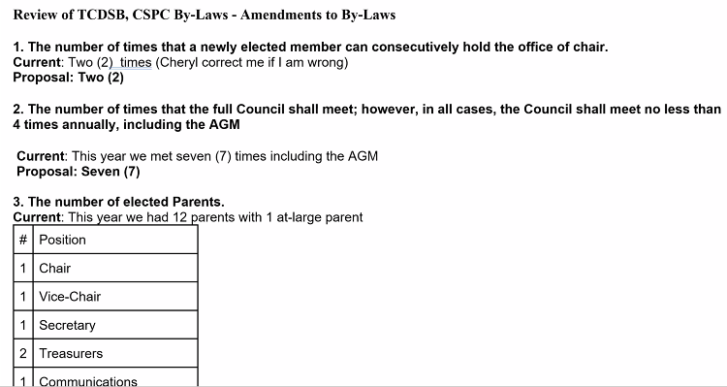
Number of elected parents.
Current: 12; Proposed: 10

Dissolving of 2020/2021 Council

Clifton proposed. Gordon seconded.

St brigid CSPC – 2021/2022 First meeting
Minutes

Nominations for Council
- Maria Puglisi
- David Forsayeth (web rep)
- Joel O’Keefe
- Marc Michalak (Church Liaison)
- Katherine (Katie) Young
- Becky Pereira
- Gordon Finlay (member-at-large)
- Bellamy Lacay
- Danielle Pollington
- Kelly Mahoney-Getz
- Siobhan Flanagan
Next week: council will vote on positions (Sep 30)
- In the week between this + the Inaugural meeting, members can meet via Zoom if they would like to discuss positions. Or it can be done at the next meeting.
Everyone was Acclaimed (by Ms. Blanchet) – all are members of council

Next Meeting
Inaugural Meeting September 30, 2021 | 7:00 p.m., via Zoom Link from Ms. Blanchet
Motion to adjourn was made at 7:45 p.m. and passed unanimously.

