St. Brigid Catholic School Annual General Meeting and CSPC Meeting DRAFT MINUTES
Thursday, November 24, 2022, 6:30 pm
In Person Attendees: Richard Waldo (Host/Principal), Lorraine van Zon (VP), Cheryl Devine (Co-Chair), Joel O’Keefe (Secretary), David Cramer (Treasurer), Kristen Hawkeswood (Special Events Rep), Leila Stamatakis (Church Liaison), Linda Collins-Donleavy (Teacher Rep), Liz Liberty (Vice Chair), Annette Paul
Remote Attendees: Alana Karelson (Communications Rep), Laura Hincopie (Web and Social Media), David Forsayeth (Member at Large), Elliot Furlano, Kelly Sequeira, Laura Hincapie, Renee Ferguson, Rosa
A motion was circulated via email on Wednesday, November 16th, 2022, by Cheryl for approval of $125 to cover the cost of 40 kids' entry fees into Waterloo University's Beaver Computing Challenge for grade 5-8 students ($3 each, plus a $5 admin fee). The motion was seconded by David and approved by Bekki, Laura, Leila, Maria, David, Liz, Kristen, David and Joel via email reply. Motion passed.
Agenda
Topic
1. | Opening Prayer & Land Acknowledgement | C. Devine / K. Young
2. | Introductions | L. van Zon
3. | Stating of other business; review of minutes & online votes  - October minutes; BCC approval | C. Devine / K. Young
4. | Principal & VP’s Report | R. Walo / L. van Zon
5. | Teacher Rep’s Report | L. Collins-Donleavy
6. | Treasurer’s Report | D. Cramer
7. | Web / Communications report | A Karelson / L. Hincopie
8. | Church Report | L. Stamatakis
9. | Special Events Report  - Request for Fun Fair Lead; tentative date  - Babysitting course date | K. Hawkeswood / B. Draper
10. | Chair’s Report  - Pizza update  - Fundraising update  - Parent Survey  - PRO grant | C. Devine / K. Young
11. | Other Business
12. | Adjournment

Summary of Motions and Action Items from this meeting:
- Motion to approve the minutes from October meeting from Cheryl. Motion seconded by Kristen. No opposition. Motion passed.
- Principal Walo to share number of computer devices currently available to students at next meeting
- Motion to approve $3,000 of funding for buses. Seconded by Kristen. No opposition. Motion passed.
- Motion to approve $4,250 towards scientist for the remaining classes. Seconded by Kristen. No opposition. Motion passed.
- Motion to allocate $1,250 for theater plays for grades 4-8. Seconded by David Cramer. No opposition. Motion passed.
- Motion to allocate $300 for Rocks and Rings. Seconded by Liz. No opposition. Motion passed.
- Motion to allocate $4,000 to the teacher allocation. Seconded by Kristen. No opposition. Motion passed.
- Principal Walo to follow up with teachers to confirm need and interest for individual document cameras.
- Motion to approve $500 for babysitting course subsidy. Seconded by David. No opposition. Motion passed.
- Motion to submit a PRO grant program related to Math. Seconded by Kristen. No opposition. Motion passed.
- Motion to adjourn meeting by Katie. Cheryl seconded. No opposition. Meeting adjourned @ 8:52 pm.
Meeting commenced at 6:33 pm
- Opening Prayer & Land Acknowledgement
Land acknowledgement was shared by Ms. van Zon.
Out of our deep respect for Indigenous peoples in Canada, we acknowledge that all Toronto Catholic District School Board properties are situated upon traditional territories of the Anishinabek, the Haudenosaunee, Confederacy and the Wendat peoples. We also acknowledge the land covered by Treaty 13 is held by the Mississaugas of the Credit First Nation, and Toronto is subject to The Dish with One Spoon covenant. We also recognize the contributions and enduring presence of all First Nations, Metis, and Inuit peoples in Ontario and the rest of Canada.
Ms. van Zon presented the prayer. Advent starts on Sunday Nov 27. First week is focused on hope. Ms. van Zon then shared an advent prayer.
- Introductions
Introductions were deferred.
- Stating of other business
Any other business to be added to the agenda. No items.
Meeting minutes can be found on the St. Brigid CSPC website and accessed here
Motion to approve the minutes from last meeting from Cheryl. Motion seconded by Kristen. No opposition. Motion passed.

- Principal & VP’s Report
- 2021-2022 EQAO Results

Grade 3 School Results Grade 6 School Results
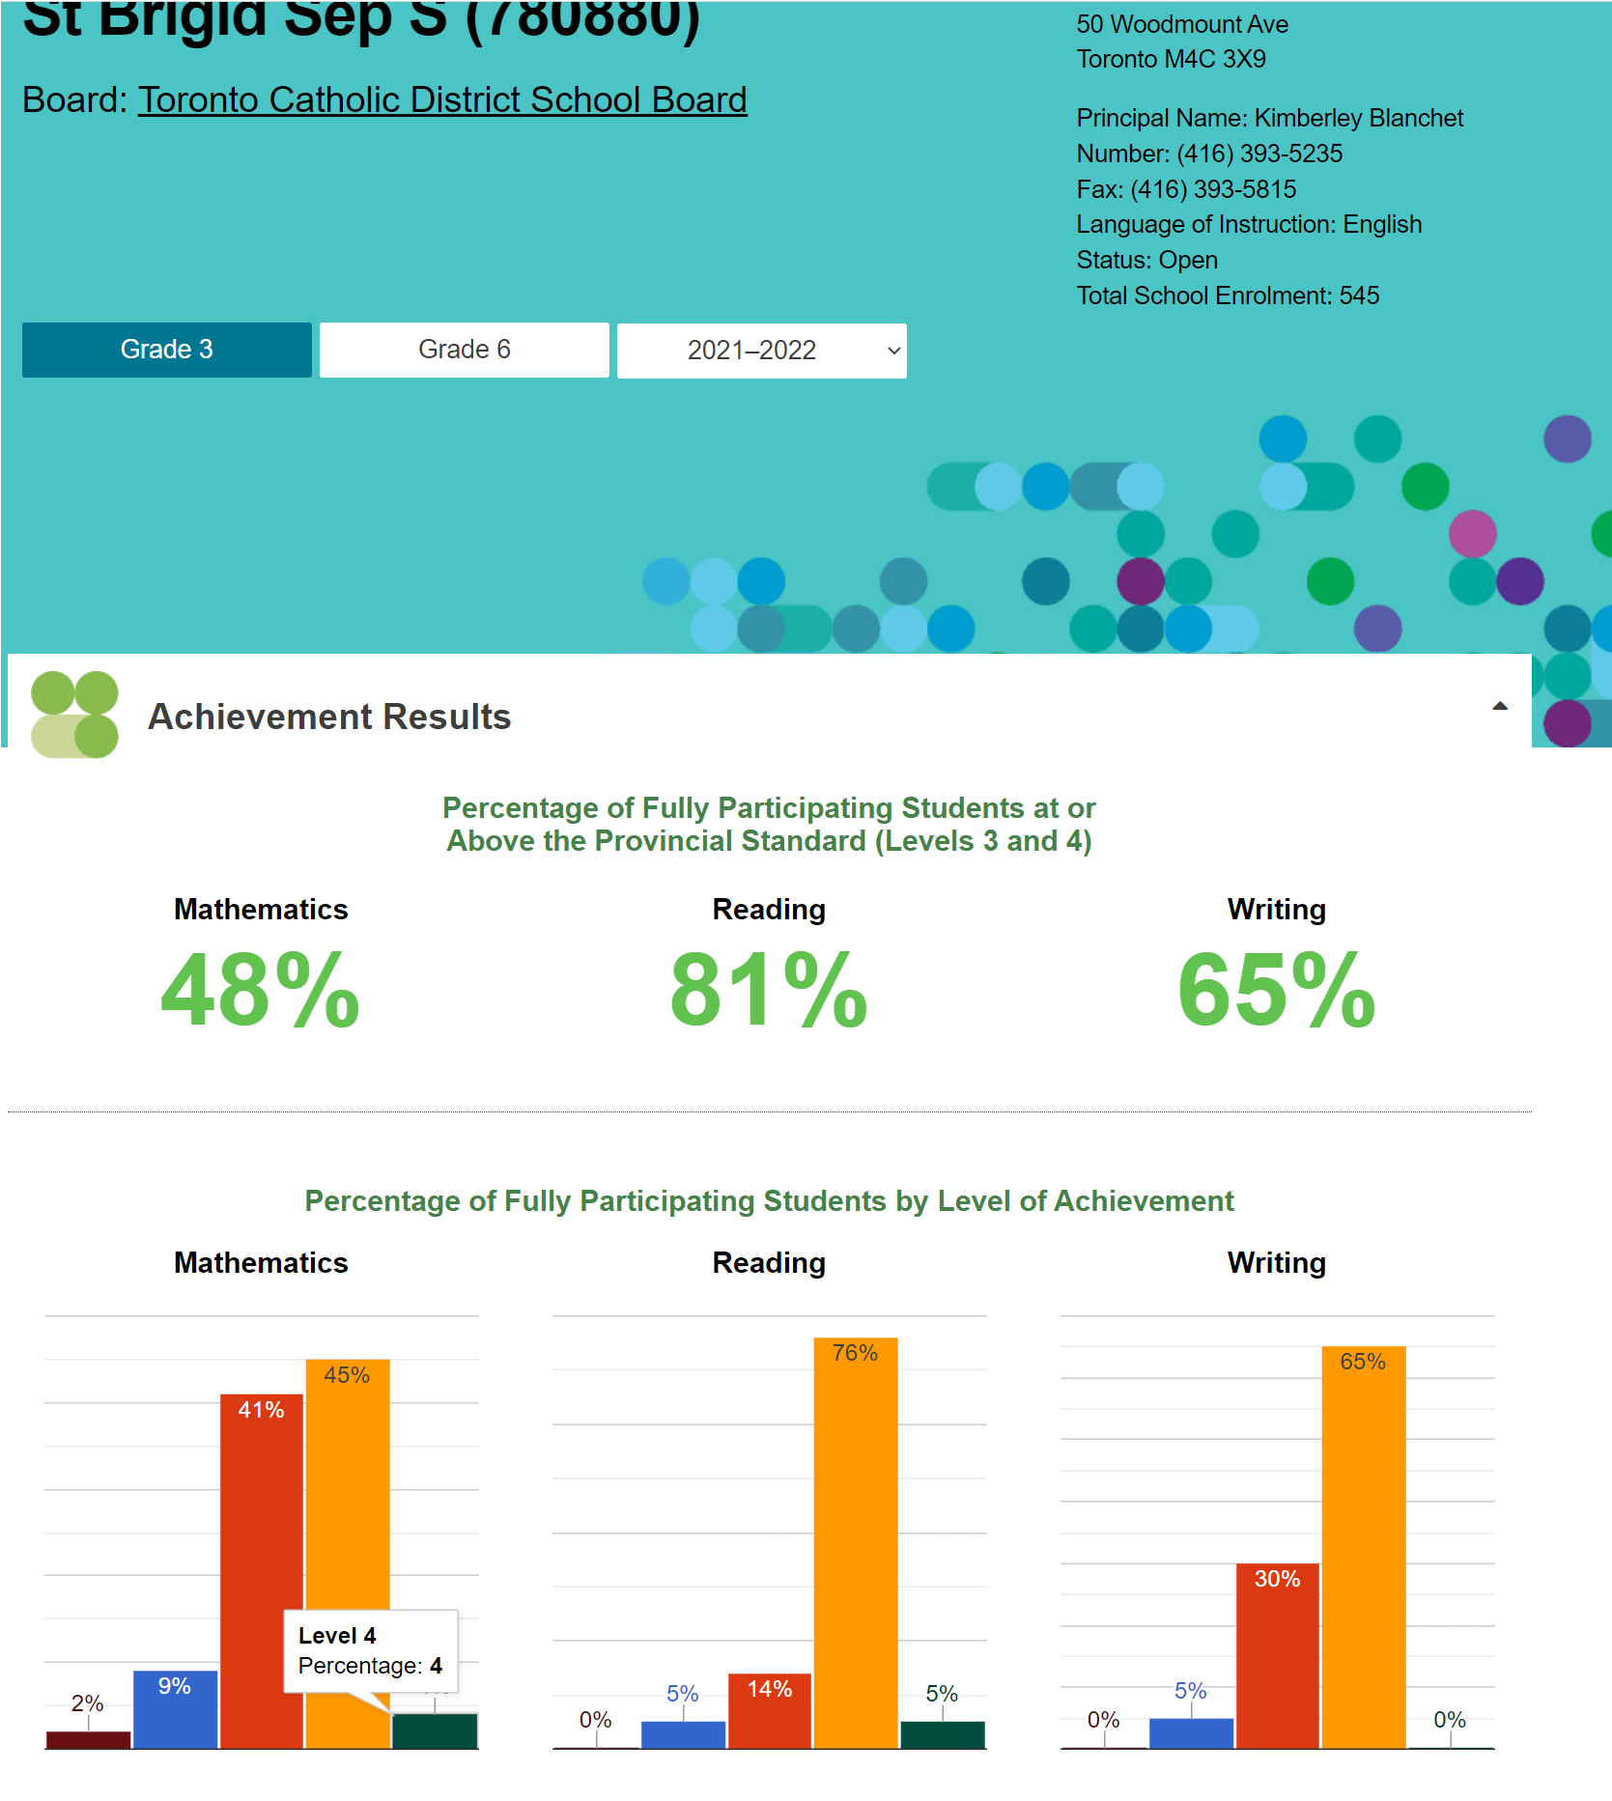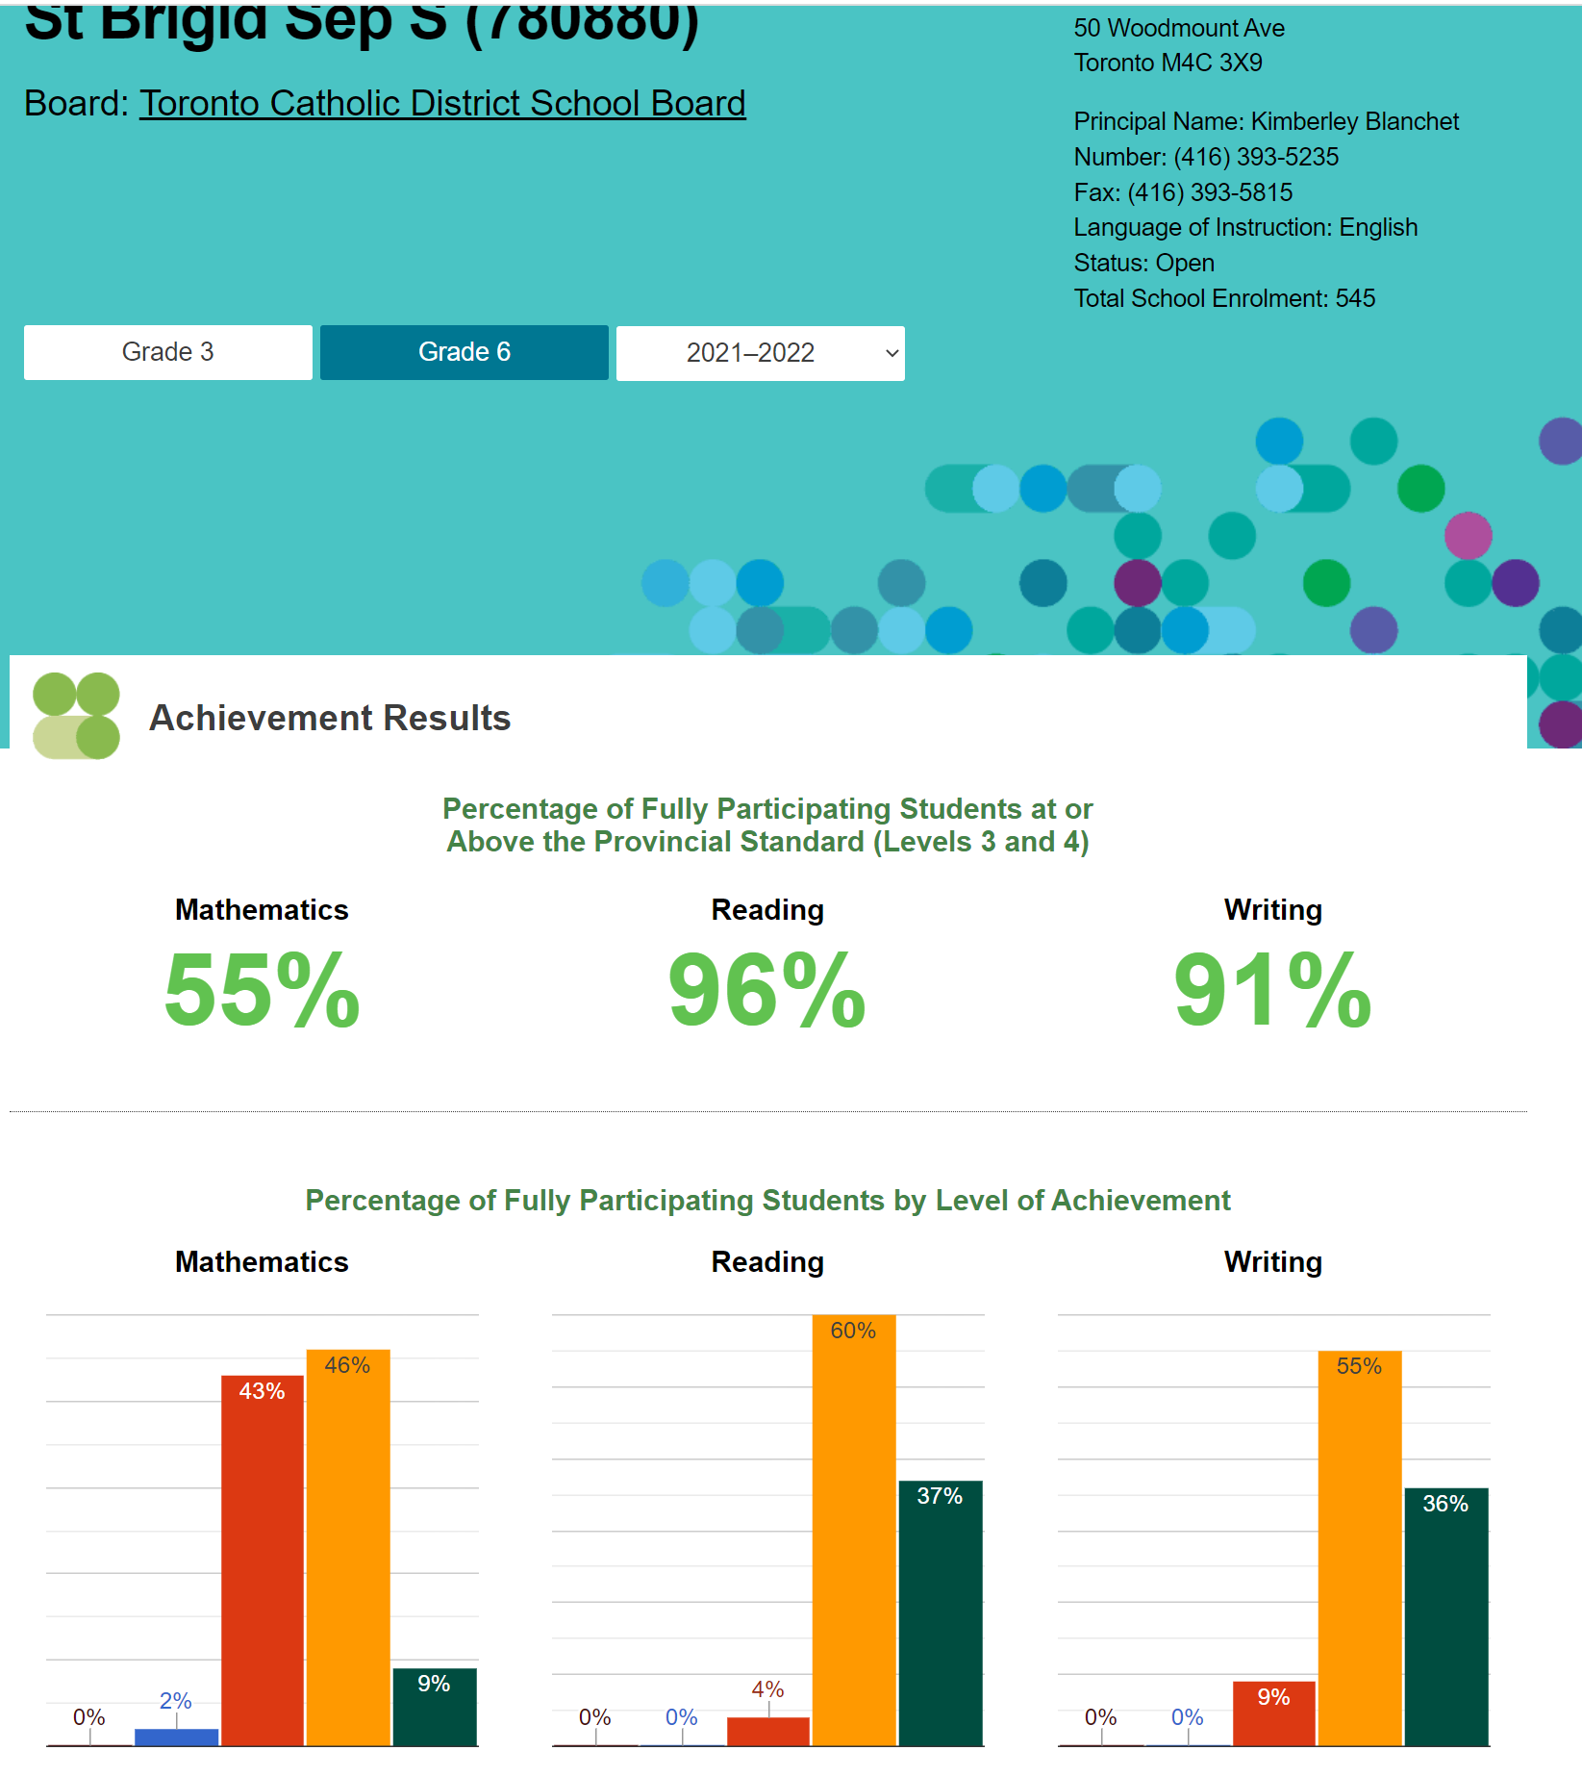

Grade 3 Provincial Results Grade 6 Provincial Results
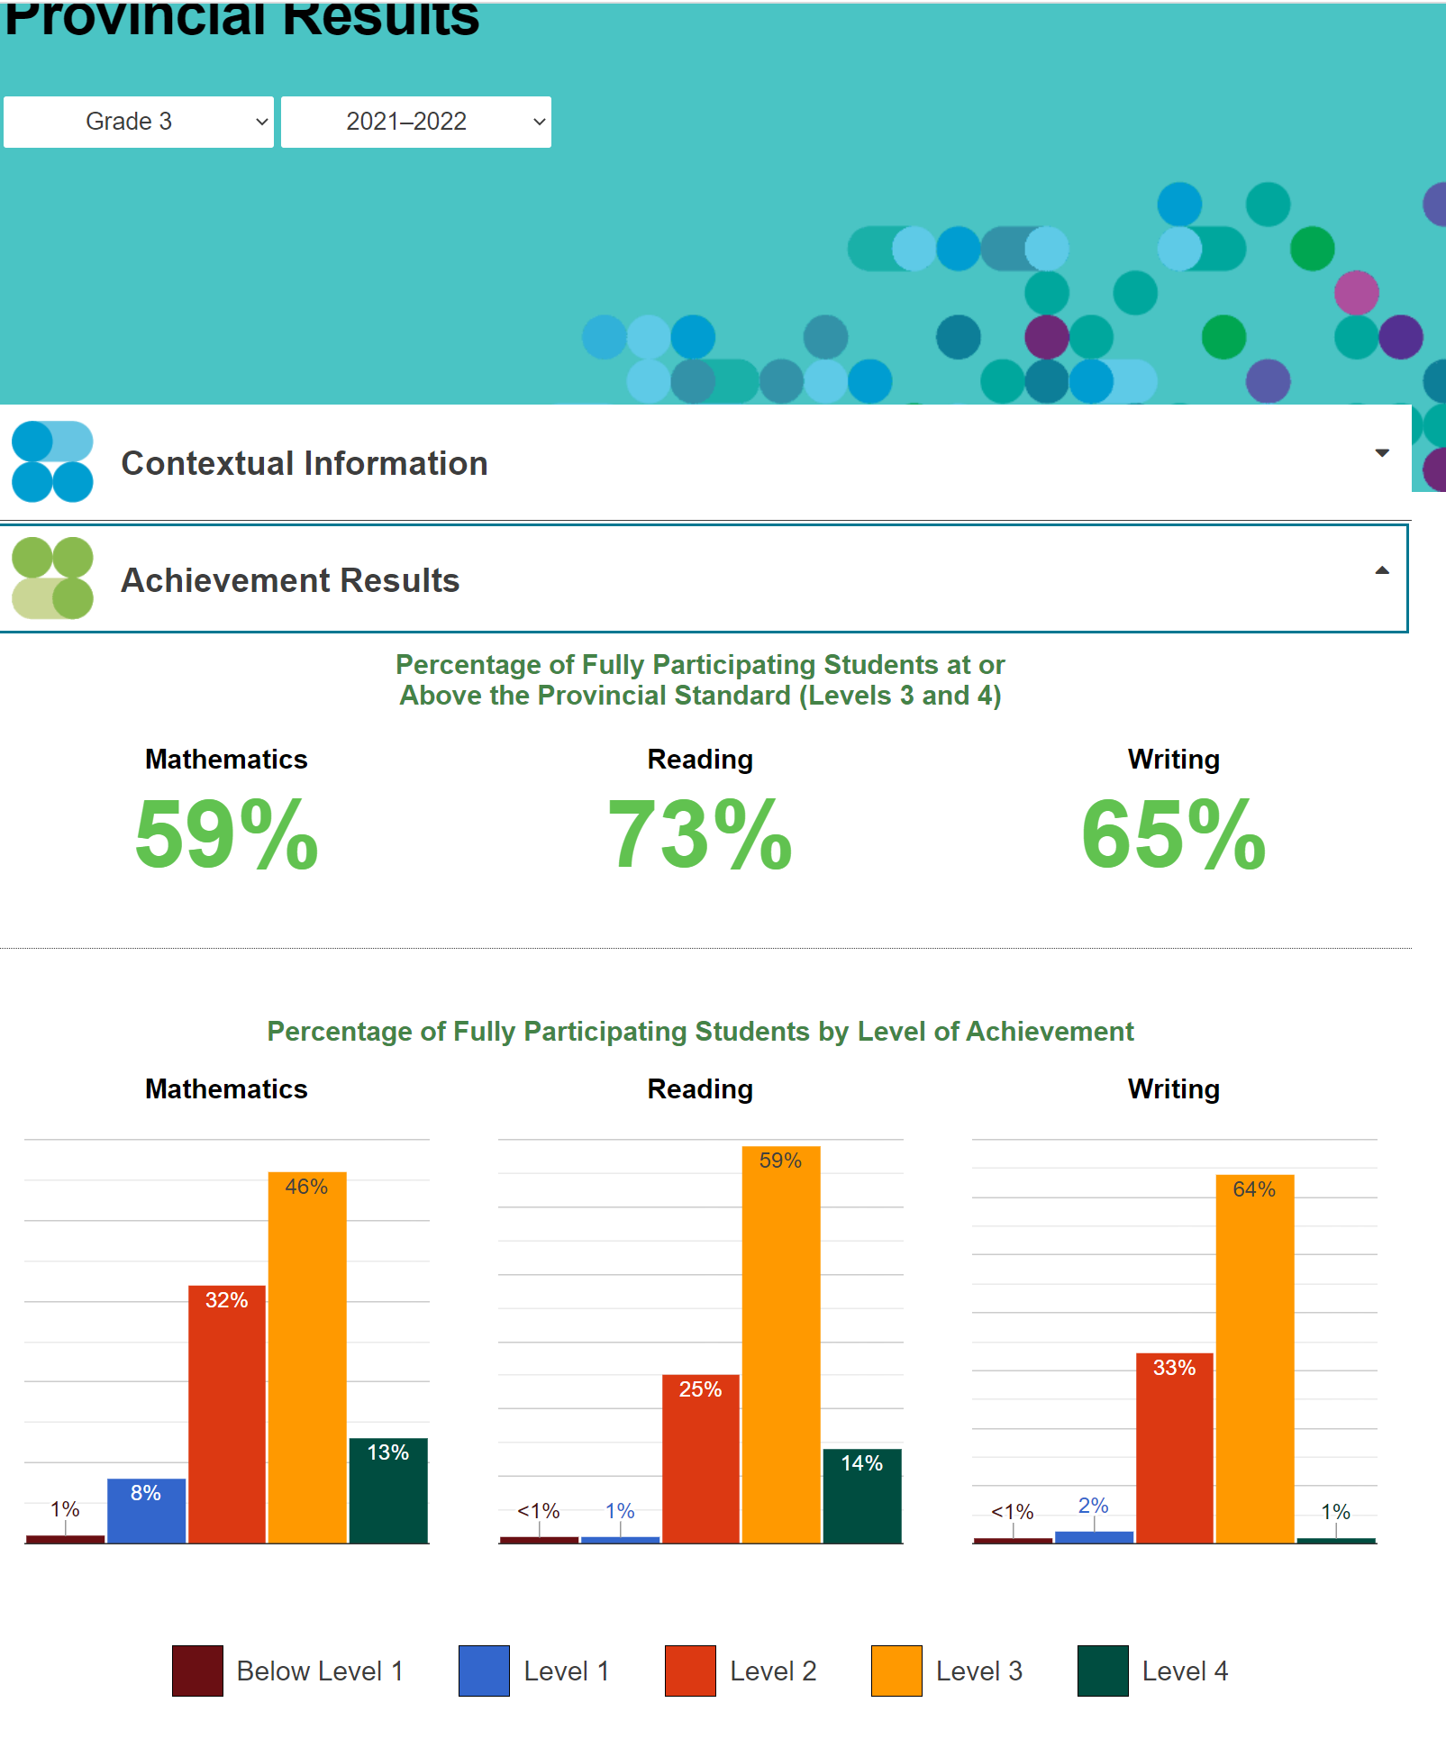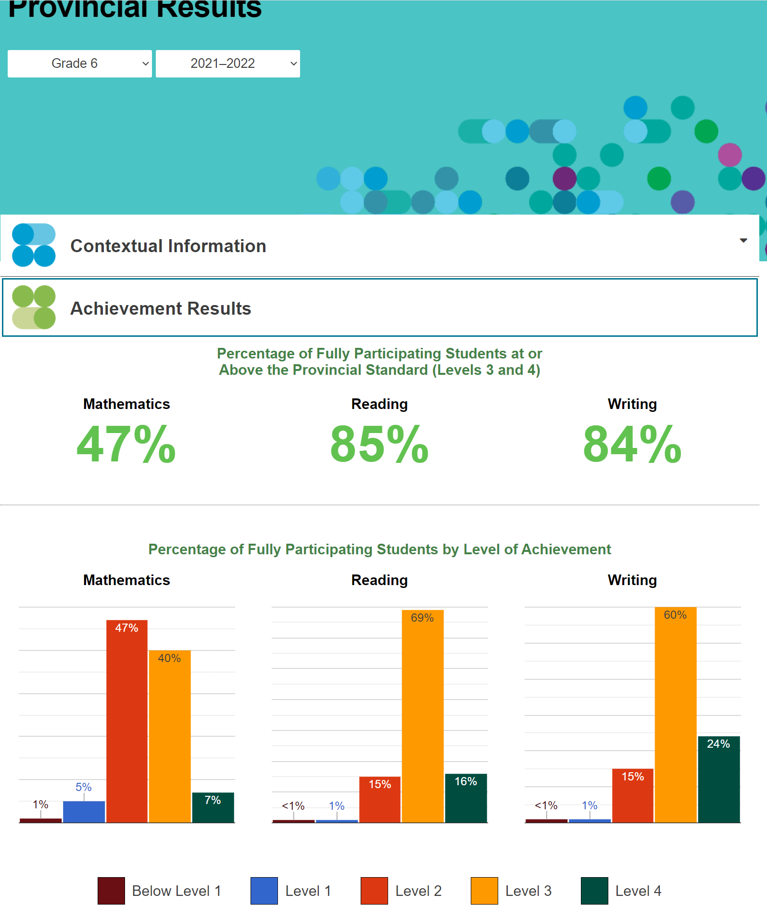
Individual results were recently distributed to students

The report outlines how the child did on reading, writing and math. School performed very well considering all the different factors over the last year.

Reports provided summaries to determine areas of focus going forward. Results are limited in capacity as they are based on last years cohorts. We actually use a five-year average to get a more balanced view.

Where an area of focus is agreed this will be shared with the parent community. Math continues to the focus area for now. Are aiming to move focus groups of students to the provincial standards of level 3.

Reading and writing results were fantastic as we scored well above the Board and province. Results for comparison purposes are shown below. All this information is available publicly.

Primary math is below the Board and province and will be an area of focus and we will seek guidance from the staff.

There were some questions on were there any surprises from the results. Yes grades 3 and 6 were surprising. Focus will be here but also school wide.

Questions related to available devices for testing going forward. Chrome books have been procured for grade 6’s. Principal Walo provide number of devices at next council meeting.

Plan coming from the results was share with the superintendent who approved the plane. Continue to work on inclusion. We are a pilot group for anti racism bias and have completed one module.

Mental health and well being will be tied into all our planning.

Career and high school planning also is a focus area for grades 1-8.

Q – Do you compare results of grades over years as a reference?

A – Yes, we do, and we also look at a five-year average to identify trends that we will try and address going forward.

Principal Walo will look to update the information and provide it in the principal’s report.

- School Improvement and Equity Plan (SIEP)
- We recently met with our School Superintendent to present our plan.
- The plan is to be actionable, time-oriented, and measurable and will be posted to school site

Achievement Goal
- 80% of students, who are currently below the Provincial Standard, will improve in Mathematics. Achievement will be measured by comparing the Term 1 and Term 2 Report Card.
- The School Improvement Team and school staff will be analyzing individual results in greater detail for trends and areas of greatest need
Equity Goal
- Staff will complete 1-3 modules of Anti-Racism training using the ‘BodySwap’ software program by June 2023. We will create an Equity, Diversity, and Inclusion Parent Committee. Monthly updates to be provide at CSPC Meetings.
Mental Health and Well-Being
- Our school will promote the TCDSB Pastoral Plan and implement several strategies to promote Mental Health and Well-Being.
Pathways and Transitions
- By June 2023, all students in Gr. 1 -8 will engage in the exploration of different career pathways via technology and virtual experiences and complete a reflective journal entry in their online portfolio (All About Me, my Blueprint).

III. Staffing Updates

- .50 ESL Position – Ms. Zaleski-Cox began in the position on Monday, November 21st.
- .40 French Immersion Specialty Teacher Position– Ms. Zimmerman began in the position on Thursday, November 24th
- Full-Time Grade 7 –Mr. Gomes began in the position on Monday, November 7th
- .50 International Languages Teacher – currently remains OPEN

Working toward filling this position which is the last open position.

Principal Walo would like to thank the parents for their patience and understanding on this matter.

IV. Equity, Diversity, and Inclusion

GSA
- GSA meets on a weekly basis
- The group will be sharing their mission statement with the community very soon
- Students provide valuable updates and information during morning announcements
- GSA will post information on the bulletin board outside the main office
- Updates will be shared throughout the year

Very positive and encouraging feedback. Looking to branch out to include students outside of the association.

Some posters were vandalized with homophobic remarks. This behaviour will not be tolerated and will be addressed. This just reinforces the need and importance of the GSA and the messages being developed there.

BSA
- Students continue to meet regularly
- Group continues to grow
- Topics being discussed include: Hair, Colourism, Stereotypes, White Supremacy, Appropriation, Representation, Long-Term Effects of Slavery

Students are developing presentations on these topics in both present and historical contexts. Presentations are made to the community.

Q – Are these extra curricular assignments?

A – Yes

Q – What grades are involved?

A – Grades 6-8. Content is grade appropriate

Asian Student Alliance
- Student initiated
- Will be meeting each month to discuss ways in which the school can be more inclusive
- Will be planning events for Asian Heritage Month in May

Group is now seeking out a teacher sponsor for the Alliance. School has unwavering support for these groups which is also backed by the council. This support is much appreciated.

Safe Schools Ambassadors
- 8 (grade 7 & 8) students attended the Safe Schools Conference on November 23rd
- Will be making regular announcements on the PA
- Determine how to continue to make our school is safe and inclusive

Meeting is scheduled for tomorrow to discuss how the information can be brough back into the St Brigid community.

Student Council
- Students submitted their speeches and will be presenting to the school on Wednesday, November 30th

Submissions will be reviewed so students can be selected to present their material back to the broader student group.

All these initiatives are intended to develop leadership skills.

Q – Are all students eligible to run for Council?

A – Students will be selected based on their submissions and then asked to present back and become candidates for Council.

A – Next year looking to eliminate names from the submissions.

- UPCOMING EVENTS in December

Santa Visit – Brightpics will be at the school on Thursday, December 1st to take photos of students in Kindergarten – Grade 3 with Santa. All students will receive a FREE photo.

Christmas Concert – Event will be held in the school gymnasium on Tuesday, December 6th and Thursday, December 8th. Please refer to email sent on Wednesday, November 16th. Thank you to the St. Brigid staff for all their efforts in preparation for the concert! Parents interested in decorating the gym are needed. Decorating will occur on Monday night.

Students who are unavailable one night may request through their teacher to participate on the other evening.

Q – What about filming of the concert?

A – No we will not allow concert filming. However, you may take photos of your child.

Q – What about using the church for the concert?

A – The gym was chosen to contain the students and use the classrooms as holding rooms. The size for attendees was similar between the two venues. Happy to revisit the decision at later dates.

Ms. Collins Dunleavy suggested that the songs may not be appropriate for the church.

Q – What about extended families? It seemed to work previously in the church.

A – Right now unable to accommodate additional attendees. Committed to revisiting the best way to present the concert in the optimal location going forward.

Q – Will there be something for grades 7 & 8’s.

A – Yes, looking to include these students as MC’s or stagehands. Will look to put off a spring concert which could include an instrumental component.

Q – What’s the estimated running time?

A – Need to confirm but expect it to be approximately an hour in duration.

Q – Do you need any council support?

A – Yes, if you could help prep the gym the night before without taking away seating capacity.
If you are interested in helping, please reach out to the Council.

Q – Are any food and beverage needed?
A – No thank you.

Advent Wreaths – There will be an Advent event with Father Shibil who will be visiting the school on Tuesday, November 29th to bless the school wreaths.

Raptors905 Game – Students in Grades 5-8 will be attending the game on Monday, December 5th. Parents are invited to attend. Scotiabank arena with tipoff at 11 and kids will be back at the school by 2pm. Cost is $20 and assistance is available.

Christmas Spirit Week – daily events planned for the week of December 19th-23rd

We will be reaching out for ideas for Spirit Week.

Mass is scheduled for Dec 21 for students of all grades. Will ask for special mass for grades K-2. Details will be shared in the Dec newsletter.

- Teacher Rep’s Report
Thanks for the funding of the buses and the scientists in the classrooms. Additional grades hope to receive the same bus funding.
List of requests remains the same as last meeting. An additional request for dance classes is requested.
Additional activities are being evaluated and may be brought forward.
Document cameras have been requested. Additional Chromebooks are also being requested.
Timing of requests is being finalized and will be shared. Request is asked to provide associated funding with each request. Will work closely with treasurer going forward to align on the priorities.
Q – What are document cameras?
A – Devices that allow the teacher to share, modify and download documents that are projected in the classroom. Really makes a difference in the lessons.
Q – is the request for one per classroom?
A – ideally one per classroom. These cameras are also very useful for remote learning and make a huge difference in the lesson delivery.
If we were to provide one per class, then the estimated cost would be approximately $4,500.
We should go back to the teachers to confirm they would use the cameras in their classrooms.
- Treasurer’s Report
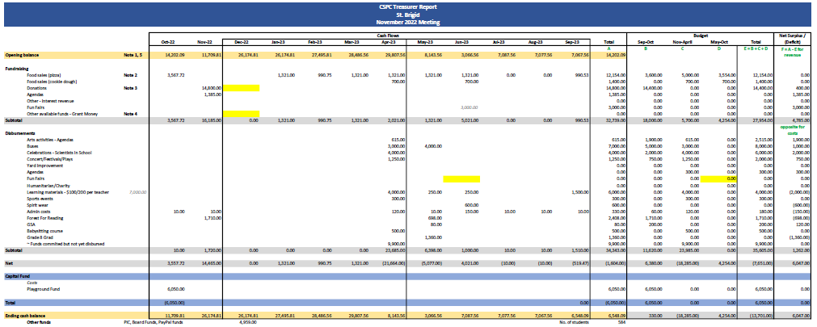
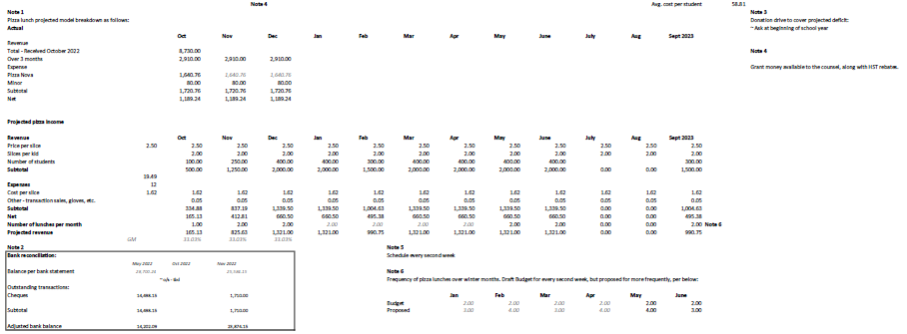
Pizza and fundraising were very successful.
Parent donation campaign has raised about $15,000.
Pizza has generated about $3,500 which has allowed us to revisit our budget and different requests.
As a council, we need to decide what we’d like to allocate the funds for.
Spreadsheet has been updated to include project expenses over the next 3 months.
Looking to save some funds for Fun Fair in the fall and teachers expenses at the end of the year.
Are we able to allocate some of the funds now based on known expenses and requests?
Current balance is $25K with some outstanding cheques which will reduce the amount to about $23K
We do have access to the $23K if we want to allocate any funds today to busing and scientists in the classroom.
We could allocate one trip per classroom, but funding may not be required at that amount due to classes sharing buses. Buses are estimated to be $350 per trip.
Motion to approve $3,000 of funding for buses. Seconded by Kristen. No opposition. Motion passed.
Motion to approve $4,250 towards scientist for the remaining classes. Seconded by Kristen. No opposition. Motion passed.
A reminder that the objective for council funding is to draw down the balance and not carry over money beyond the school year.
Motion to allocate $1,250 for theater plays for grades 4-8. Seconded by David Cramer. No opposition. Motion passed.
Motion to allocate $300 for Rocks and Rings. Seconded by Liz. No opposition. Motion passed.
Motion to allocate $4,000 to the teacher allocation. Seconded by Kristen. No opposition. Motion passed.
- Web / Communications Report
Planning to revisit the layout and content of the web site. Also looking to develop a calendar of events and communications.
- Church Report
Leila had a call with Bruna from the church who shared the following updates:
- Out of the Cold program which has several initiatives including:
- Collecting egg cartons to divide eggs bought in bulk.
- Sock drive – new socks which are donated and provided to out of the cold participants.
- Canned and non-perishable goods drive. Ongoing with an immediate need now
- Children’s Literacy at mass. Taught the gospel in a more friendly way. Only getting 5 or 6 kids attending.
- Looking for Grade 7 or 8’s to take on some volunteering including passing out parishioner envelopes at mass.
- Confirmation registration closed on Nov 11. Those who missed the deadline call the church and will try to accommodate the requests.
- Confirmation began and students received their crosses.
- Asking students to write a small message about their understanding of the homily.
- First grade 2 reconciliation class starts on Saturday at 3pm.
- Principal Walo will send out all the dates in the weekly update.
- Church is looking to start up their Youth Group again which was paused by Covid. Updates to come.
- Choir was paused during Covid. Looking to resume the adult choir and potentially start up a Youth choir.

- Special Events Report
- Request for Fun Fair
  - Alana is nominated to be council rep on the Fun Fair committee
  - Fun Fair subcommittee will meet to select a date prior to year end
- Babysitting Course
  - Friday January 13th – PA day. 10 students minimum with a 25-student maximum. Grades 6, 7 & 8. Full day (5-6 hours). Only requirement is a screen. $40 per participant. Council would subsidize the event by $20 and then the students would provide 2 hours of babysitting.
  - If there is additional interest, we could look to book another event later.
Motion to approve $500 for babysitting course subsidy. Seconded by David. No opposition. Motion passed.
- Chair’s Report
- Pizza Update
  - Two dates left in this school
  - Over 700 slices ordered
  - Would like to move back to munch lunch form cash online
  - Pizza sub committee will revisit and come back with a recommendation.
  - Would like to move to weekly pizza
- Fundraising Update
  - Prize draw including all the students was held. Prize winners were announced today and sent out.
  - Prizes included lunch with Principal and VP
  - Also, Principal and VP for a day
  - Dress down day for the entire school will be scheduled for a future date as we hit our fund-raising target
- Parent teacher interviews
  - Feedback asking about food for sale
  - Blue and white sale received great feedback. Netted $120
  - Will look to continue in the future
- Parent Survey
  - Has not been circulated yet
  - If anyone able to assist it would be appreciated.
- PRO Grant
  - Information was circulated prior to the meeting
  - Review has been deferred to January
Motion to submit a PRO grant program related to Math. Seconded by Kristen. No opposition. Motion passed.
Math tutoring is available to the school. School has 150 hours available to be distributed at the discretion of the administration. There is a list of tutors. Parents interested can reach out. School will look to communicate this information.
- Other Business
No other business.
- Adjournment
Motion to adjourn meeting by Cheryl. Seconded by David. No opposition. Meeting adjourned @ 8:42 pm.
Next Meeting: Thursday, January 19th @ 6:30pm

