St. Brigid Catholic School CSPC Meeting DRAFT MINUTES
Thursday January 19, 2023 6:30 pm
In Person Attendees: Richard Waldo (Host/Principal), Cheryl Devine (Co-Chair), Katie Young (Co-Chair), Joel O’Keefe (Secretary), David Cramer (Treasurer), Kristen Hawkeswood (Special Events Rep), Leila Stamatakis (Church Liaison), Linda Collins-Donleavy (Teacher Rep), Liz Liberty (Vice Chair), Laura Hincopie (Web and Social Media), Mary Rose Leishman, Tammy Stefak
Remote Attendees: David Forsayeth (Member at Large), Elliot Furlano, Ballamy Lacay, Bekki Draper, Clifton Corbin, Lisa McAleer, Eileen Cramer
Agenda
Topic
1. | Opening Prayer & Land Acknowledgement | C. Devine / K. Young
2. | Introductions
3. | Review and voting on November meeting minutes
4. | Principal’s Report | R. Walo
5. | Teacher Rep’s Report | L. Collins-Donleavy
6. | Treasurer’s Report | D. Cramer
7. | Church Report | L. Stamatakis
8. | Special Events Report | K. Hawkeswood / B. Draper
9. | Chair’s Report | C. Devine / K. Young
10. | Other Business
11. | Adjournment

Summary of Motions and Action Items from this meeting:
- Motion to approve the minutes from December meeting from Cheryl. Motion seconded by David. No opposition. Motion passed.
- Motion to allocate funds for the following items was raised by Cheryl:
  - $2,000 for Grade 8 Grad
  - $500 Grade 2 and 7 sacrament events
  - $3,000 for additional document cameras for teachers
  - $300 for administration fees
  - $600 for Sports and Spirit Wear
  - $250 for Forest of Reading Red Maple books
  - $3,000 for Fun Fair funding
  - $4,000 for additional Teacher allocation
Motion seconded by David. No opposition. Motion passed.
- Principal Walo to follow up with the Board Facilities to determine options for yard maintenance related to freezing and flooding concerns.
- Motion to move the next meeting from Feb 9 to March 2 by Cheryl. Seconded by David. No opposition. Motion passed.
- Motion to adjourn meeting by Cheryl. Seconded by David. No opposition. Meeting adjourned @ 8:24 pm.
Meeting commenced at 6:37 pm
- Opening Prayer & Land Acknowledgement
Courage is the virtue for January.
Ms. Collins-Donleavy lead us in a prayer of courage.
Land acknowledgement was shared by Mr. Walo.
Out of our deep respect for Indigenous peoples in Canada, we acknowledge that all Toronto Catholic District School Board properties are situated upon traditional territories of the Anishinabek, the Haudenosaunee, Confederacy and the Wendat peoples. We also acknowledge the land covered by Treaty 13 is held by the Mississaugas of the Credit First Nation, and Toronto is subject to The Dish with One Spoon covenant. We also recognize the contributions and enduring presence of all First Nations, Metis, and Inuit peoples in Ontario and the rest of Canada.
- Introductions
Introductions were deferred.
- Review and voting on November meeting minutes
Meeting minutes can be found on the St. Brigid CSPC website and accessed here
Motion to approve the minutes from last meeting from Cheryl. Motion seconded by David. No opposition. Motion passed.
- Principal’s Report
Mr. Walo began his report by saying we’ve had a great start to the new year.

STAFFING UPDATES
- Ms. van Zon was recently appointed to Bishop Macdonell as the acting Principal, effective Monday, January 9th. She will be deeply missed and we congratulate her on this recent appointment! Ms. Gallo will be the interim Vice Principal at St. Brigid’s and further updates will be forthcoming.

Ms van Zon will be missed as she touched everyone in the school. We wish her well in her new role.

- Christine Barnett, CYW in the Autism ISP class was transferred to St. Kateri, effective Wednesday, December 14th. We remain in contact with Special Services regarding the needs of our school and will share updates as soon as possible.
- Welcome to Ms. Pallotta, NEW Grade 3/4 teacher. She began her assignment on Friday, December 22nd. The permanent teacher is currently on a leave of absence.
- Welcome to Jessica DaSilva, NEW Kindergarten teacher. Ms. DaSilva will begin on Monday, January 23rd. The permanent teacher is on a leave of absence.

TCDBS TECHNOLOGY ROLLOUT
- On November 22nd St. Brigid received the following devices as part of the TCDSB Technology Rollout Program:
57 ChromeBooks (NEW)
84 ChromeBooks (Refurbished)
14 Teacher Laptops for Classroom Use (NEW)
27 iPads (NEW)
- 57 ChromeBooks (NEW) were distributed to Grade 6 as part of the 1:1 rollout program
- 84 ChromeBooks (Refurbished) were distributed to remainder of students in Grades 1-8 (excluding Grade 6) based on a ratio of 1 laptop for every 5 students
- Most classrooms received a mini-charging cart to store the laptops
- 27 iPads (NEW) were distributed to Kindergarten Classrooms
- The St. Brigid School Library has the following devices:
27 ChromeBooks
27 iPads
- The current Grade 5s will receive a laptop in September 2023
- We feel as though we have ample devices for the completion of Grade 3 and 6 EQAO

New equipment to be rolled over the next year as per our Technology program.

Students are starting to put together powerpoint presentations as a result of the new technology being introduced.

AFRICAN-CANADIAN HERITAGE MONTH
- On Wednesday, February 1st, D.O. Gibson will be providing a virtual anti-bullying presentation to students in Grades1-8. D.O. is a captivating speaker and will share his experience of being impacted by racism while attending school. He will provide students with the necessary tools to combat racism. Thank you to the CSPC for covering the $450 cost of the presentation.
  - Main premise of his presentation is his experience with racism and how he persevered.
  - Is a virtual presentation for grades 1-8
- On Tuesday, February 24th, students will be attending a BHM Luncheon (virtual) with Cameron Bailey (TIFF)
  - Through the University of Toronto as an Alumni event
  - Is a focused session primarily for students celebrating black excellence
  - For grades 6,7 and 8 and if a free event
- The BSA will be leading announcements and various activities throughout the month of February
  - Will culminated with a day of presentations including a learning carousel related to anti racism
  - There is some funds available for this event under presentations if needed.
- Ms. Pedler will be arranging an African-Canadian Heritage Month display in the library
- Primary classes have arranged for a local artist to work with the students on an arts activity which focuses on BHM
  - A fee is required and students participating were presented a payment link
- The TCDSB will be announcing further information regarding workshops, student presentations and staff professional development

Black Student Alliance
- The BSA recently met this past Wednesday to discuss planning for African Canadian Heritage Month
- We are planning to continue to work closely with Renee Ferguson and Michael Avis to support the work of the BSA
- Updates will be forthcoming
  - These initiatives will continue without Ms van Zon under the leadership of Mr Walo and Ms CD. They have reached out to the community for suggestions and support.
  - GSA will also continue with more information to be shared.

ENROLMENT UPDATE
- We are in the initial planning stages for the 2023-2024 school year.
- The Planning Department has provided enrolment projections for the upcoming year. Projections consider new developments in the neighborhood, as well as historical enrolment figures. The following projections for the upcoming year were generated:

 | JK | SK | 1 | 2 | 3 | 4 | 5 | 6 | 7 | 8 | TOTAL
English | 41 | 29 | 31 | 46 | 33 | 39 | 35 | 48 | 55 | 60 | 418
French | 28 | 26 | 22 | 27 | 19 | 23 | 17 | 0 | 0 | 0 | 161

- The staff and administration will review enrolment in each grade and will submit the school’s projected model.
- We will be canvassing the community to determine plans for the upcoming year. Each child will receive an “Are you Returning” form. This will assist greatly in planning for next year.
  - Projections are due for submission on February 3.
  - A reminder will be sent out for families who are moving to advise for they can factored into the projections.

CHRISTMAS FUNDRAISING UPDATES
- $2200 raised for the Christmas Outreach Program. Donations went toward the purchasing of gift cards for families in need. Thank you to the St. Brigid community for the tremendous generosity.
- An additional donation of $3180 was received from Blessed Sacrament. This financial donation also supported families during the Christmas Season and remainder of the school year. A letter of gratitude was sent to the Blessed Sacrament CSPC for their generous donation.
  - This donation was the result of a bake sale

NUMERACY & LITERACY
- Licenses for Raz Kids were purchased for all students in Kindergarten – Grade 3. Raz Kids is an excellent reading intervention tool and provide parents with the necessary tools to support their child
- In February, teachers will be receiving professional development on the MathUp program. The program is aligned with the REVISED Math Curriculum Expectations.
FACILITIES UPDATES
- Water Drainage – The TCDSB Facilities Department was contacted on December 14th regarding the lack of drainage in the kindergarten yard area. We were advised that a solution is being investigated and that follow up will occur in the new year.
- Mirrors were recently installed in the Junior/Intermediate Boys and Girls Washrooms
  - We will continue to monitor any feedback
- Receptacles for Feminine Products were recently installed in the Junior/Intermediate Girls Washroom

Q – Is soap provided in the washroom?
A – Yes, when depleted it is to be replenished asap. It’s a must have requirement.

TCDSB Revitalization Funds Update
- A planning meeting has been arranged with the TCDSB Revitalization Team. Clifton Corbin will attend the meeting on behalf of the community. Meeting Date is Wednesday, January 25th to discuss next steps

Katie volunteered to join as a council rep.
SKATING PROGRAM
- Several classes have participated in the skating as part of their physical education program
- The Mr. Moulds skating day will take place on Thursday, March 30th
- We are currently in need of skates and helmets for older students. We are kindly requesting gently used items.
  - Office is happy to accept donations specifically for older students. May need to access high school families for donations to meet this requirement. Is there an opportunity to make an ask of Notre Dame and Gledhill for possible donations or a trade program?
  - Will also explore other options – Ted Reeves, Play it Again Sports

Q – Are there additional resources available for Black History Month?
A – Yes and they can be made available and will be shared.

Q – What’s the plan for the yard with flooding and freezing maintenance for the school yard.
A – Board has a layout plan for the year based on size and ability to access the yard. Will need to revisit the plan and options. Mr Walo to followup with facilities.

Q – Are we able to donate salt for melting ice
A – There is a liability concern with introducing new materials or supplies

There are some short term solutions (removing leaves) that we can manage and we will continue to explore options.

A formal request was made to the Head of Facilities. Feedback was that something will be done.

- Teacher Rep’s Report
Request for more funding for Forest of Reading
Teachers are wondering if they need to use the same spreadsheet for submitting receipts
Rocks and Rings was booked for May. There was a credit that we could use so no additional funds required
Waterloo math initiative was the Beaver Computing Challenge, which CSPC funded in November ($125 for 40 kids in grade 5-8). The event went very well with a number of students performing extremely well.
Grade 8’s did candy cane grams that resulted in raising funds for the grad trip
Teachers looking for clarification on requesting buses and if they could use bus funds for something else.
Is there is an option of reallocating bus funds for another purpose (maybe related or not). Preference is to use bus allocation for buses.
Allocation we’ve made cover large kid buses and not necessarily the small kid buses. We may have under funded the bus need. Presently the number of requests have consumed a majority of the funds but this needs to validate after receipt of the spend.
- Treasurer’s Report
Projecting $38,000 in the bank after outstanding cheques are cashed. Is more than we expected to have.
We received an unexpected HST checque for $3,000
Pizza money has overdelivered
We could consider adding additional funding requests
Parents are welcome to come back with additional suggestions or requests for funding.
Ms. Collins-Donleavy has a spreadsheet with all the spending and can help with the estimates
May want to increase any suggestions by 30% to account for inflation.
Want to make sure all the grad are able to participate in the grad activities and trip and receive a grad hoodie
Will ask for grade 7 participation in the grad setup and should be part of a communication a month before the event. More details to come during Feb meeting.
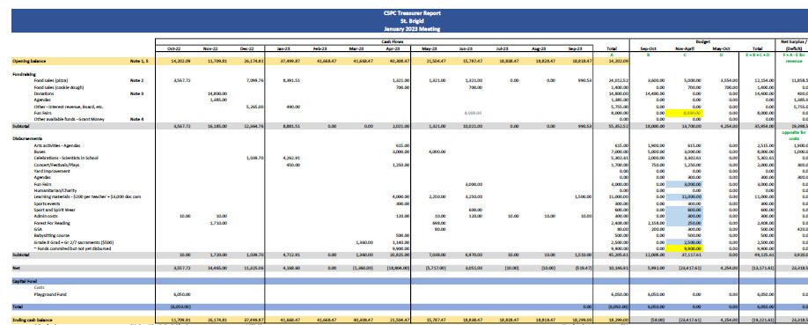
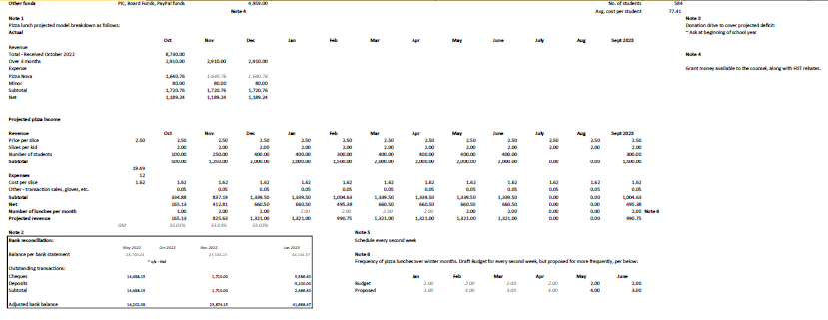
Motion to allocate funds for the following items was made by Cheryl:
$2,000 for Grade 8 Grad
$500 Grade 2 and 7 sacrament events
$3,000 for additional document cameras for teachers
$300 for administration fees
$600 for Sports and Spirit Wear
$250 for Forest of Reading Red Maple books
$3,000 for Fun Fair funding
$4,000 for additional Teacher allocation
Motion seconded by David. No opposition. Motion passed.
Will ask teachers to submit receipts for expenses prior to May 31.
- Church Report
Church is back on regular schedule
Catechism resumed this week as well as reconciliation classes.
Participants are asked to submit essay that are reviewed with the best submissions being asked to read them during mass.
Ash Wednesday is February 22, 2023.
Jr Kindergarten registration has begun
- Special Events Report
Fun fair tentatively planned for Saturday, June 10
Babysitting class ran very well. 25 kids. Next session is scheduled for June 22.
- Chair’s Report
Second session of pizza rolled out successfully. Thanks to all the pizza volunteers.
Two positions on Council still open. One is special ed rep as a member had to step away. Role is to play point for any questions and review Special Ed committee meeting minutes or video. Acts a liaise for the school
OAPCE rep is still open. Chairs are currently filing the role. Sessions are good and have relevant and great speakers.
Funding for Family / Community event has been made available ($500). We now have about $1800 to put towards an event. Are currently evaluating different options for this event. Tribal Vision Dance was mentioned as one option from Prologue to the Performing arts, a company that offers many different educational shows/workshops that schools often book. Bookings are usually during school hours but could inquire if some groups may book off-hours for an evening family learning evening, covered using PIC funds and potentially a Math theme night. Small fundraiser aligned with interview night (Feb 14 or 16) for Gr 8 grad or Teacher appreciation.
January 27 is Family Literacy Day and we may want to suggest a family reading list with the theme of celebrating our heritage
Motion to move the next meeting from Feb 9 to March 2 by Cheryl. Seconded by David. No opposition. Motion passed.
May have a later request for funding for Pancake Tuesday.
- Other Business
No other business.
- Adjournment
Motion to adjourn meeting by Cheryl. Seconded by David. No opposition. Meeting adjourned @ 8:24 pm.
Next Meeting: Thursday, March 2nd, 2023 @ 6:30pm

