St. Brigid Catholic School CSPC Meeting DRAFT MINUTES
Thursday March 2, 2023 6:30 pm
In Person Attendees: Richard Waldo (Host/Principal), Cheryl Devine (Co-Chair), Katie Young (Co-Chair), Kristen Hawkeswood (Special Events Rep), Leila Stamatakis (Church Liaison), Linda Collins-Donleavy (Teacher Rep), Liz Liberty (Vice Chair), Clifton Corbin, Lisa McAleer
Remote Attendees: Joel O’Keefe (Secretary), David Forsayeth (Member at Large), Laura Hincopie (Web and Social Media), David Cramer (Treasurer), Alana Karelson (Communications Rep) Ballamy Lacay, Karolina Martinez, Michelle Mifsud
Agenda
Topic
1. | Opening Prayer & Land Acknowledgement | C. Devine / K. Young
2. | Introductions
3. | Review and voting on January meeting minutes
4. | Principal’s Report | R. Walo
5. | Teacher Rep’s Report | L. Collins-Donleavy
6. | Playground Update | C. Corbin
7. | Treasurer’s Report | D. Cramer
8. | Special Events Report  - April Family Event Night  - Fun Fair | K. Hawkeswood
9. | Chair’s Report | C. Devine / K. Young
10. | Other Business
11. | Adjournment

Summary of Motions and Action Items from this meeting:
- Motion to approve the minutes from January meeting by Cheryl. Motion seconded by Kristen. No opposition. Motion passed.
- Motion to allocate 2 weeks of pizza funds to teacher appreciation by Cheryl. Seconded by Kristen, No opposition. Motion Passed.
- Motion to spend $200 of parent involvement program on presentation of Financial Literacy by Cheryl. Kristen seconded. No opposition. Motion passed.
- Motion to appoint Lisa ? as the OAPCE rep. Seconded by Katie. No opposition. Motion passed.
- Motion to adjourn meeting by Cheryl. Seconded by David. No opposition. Meeting adjourned @ 8:34 pm.
Meeting commenced at 6:35 pm
Cheryl shared that two motions were passed with council member majorities via email since the last Council Meeting on February 16.
- $300 to support Shrove/Pancake Tuesday hospitality supplies
- $200 for folding tables for pancakes, pizza and future events.

- Opening Prayer & Land Acknowledgement
Ms. Collins-Donleavy lead us in a prayer for Lent and Grace.
Land acknowledgement was shared by Mr. Walo.
Out of our deep respect for Indigenous peoples in Canada, we acknowledge that all Toronto Catholic District School Board properties are situated upon traditional territories of the Anishinabek, the Haudenosaunee, Confederacy and the Wendat peoples. We also acknowledge the land covered by Treaty 13 is held by the Mississaugas of the Credit First Nation, and Toronto is subject to The Dish with One Spoon covenant. We also recognize the contributions and enduring presence of all First Nations, Metis, and Inuit peoples in Ontario and the rest of Canada.
- Introductions
Introductions were deferred.
- Review and voting on January meeting minutes
Meeting minutes can be found on the St. Brigid CSPC website and accessed here
Motion to approve the minutes from last meeting from Cheryl. Motion seconded by Kristen. No opposition. Motion passed.
- Principal’s Report
School year moving along well. Pancake and Pizza Tuesday went well and were very well received.

- STAFFING

- Alex Eckert, Core French Teacher, recently accepted the .60 French Specialty position at St. Cyril, as of Monday, February 27th. We welcome Elizabeth Cramp back to St. Brigid, as she will be replacing Mr. Eckert as the new 8s. Core French Teacher
- Ms. Mullally, Instrumental Music Teacher, is currently on leave. We are pleased to announce that Katryn Zaleski-Cox will be providing Art/Music lessons to Gr 7s and

Information shared today with Gr 7 & 8’s proposing an afternoon band program. Scheduled to start next week after school. Letter will be sent home to parents with program information. May end of being switched to a lunch time offering.

Q - Will we be filling the open Music Teacher role?
A - Remains actively posted.

Q - Will students be able to take instruments home?
A - Ideally the sign out program will be offered to kids who partake in the program. If you have questions, please reach out to Mr. Walo. There is a choir opened to all students.
We are working creatively to provide music and arts programs to the students.

- Welcome to Julianna Trentadue, NEW Lunchtime Supervisor who begins in her role on Monday, March 6th. She will be a permanent staff member in Monday through Friday.

- LIBRARY
- On Sunday, February 5th, the school experienced a flood, which impacting several classrooms and areas in the ‘old building’
- Over the past several weeks, floor tiles and ceiling tiles were removed in replaced in several rooms. Many of the rooms impacted by the flood will be painted
- Facilities will continue its deep cleaning of the library and other areas impacted – most of the work has occurred on evenings and will continue during the March Break
- The Occupational Health and Safety Department has requested air quality tests for the areas/spaces impacted. Updates will be shared with the community
- In total, there were approximately 2000 books destroyed – they have been discarded
- The Risk Management Department will be working closely with the school to ensure that all damaged items are replaced in a timely manner
- We appreciate all of Ms. Pedler’s hard work in taking inventory of damaged books. All this information will be shared with Risk Management Staff.

Q - Does Risk Management take inventory of the books that were damaged and not salvageable?
A - Yes, an inventory and record was kept.

Q - Is anyone evaluating the content and appropriateness of books in the library.
A – Yes, periodic reviews of the books are conducted to ensure books reflect a variety of cultures and topics.

Teachers are regularly engaging with Ms. Pedler on books to be place in the library inventory.

- SCHOOL IMPROVEMENT
Literacy
- The school will be placing an order for guided reading materials for the French Immersion program (Kindergarten – Grade 2). Classroom teachers will share updates with parents.
- Guided Reading resources for the English Language program will be ordered for students in Kindergarten – Grade 2. Classroom teachers will share updates with parents.

Numeracy/Coding
- The TCDSB Math Department will be providing MathUP Professional Development workshops to St. Brigid Teachers in April
- We continue to focus on moving students to the Ministry Standard (Level 3 or B range) in Math (and Language)
- The school has borrowed a 3D Printer from the TCDSB which is currently being used by the Grade 7s. We have access to the printer for a 3-week period. We will be exploring future opportunities to have the printer back at St. Brigid

- FACILITIES
Playground Revitalization
- On Tuesday, January 24th, the school administration met with the TCDSB Landscape Architect to discuss solutions to the drainage issues experienced in the front yard
- It was recommended that we explore a natural softscape drainage solution. The drainage would be like the existing area in the Western corner of the front yard.
- The work would be classified as a Capital Project and would be included in next year’s budget. If all goes as planned, construction could occur in the summer of 2024.

Mr. Walo expressed an interest to move forward with the project to ensure our request would be placed in the queue.

- BLACK HISTORY MONTH

- The Black Student Alliance (BSA) has worked tirelessly this past month planning several African Canadian Heritage Month initiatives
- On March 2nd and 3rd the BSA organized a ‘Black Excellence’ showcase for students in Kindergarten – Grade 8. There were information booths setup focusing on a wide variety of themes including: Cultural Appropriation, Representation, Hair, Stereotyping and other prominent community leaders.
- We are incredibly grateful to the students for their exceptional work this year and would like to thank the following school staff for their assistance in planning the Black Excellence Showcase: Ms. Collins-Donleavy and Ms. Patres
- The BSA will continue to meet regularly to discuss issues related to racism and systemic discrimination, and will work closely with the school administration with its school-wide efforts around anti-racism
- Teacher Rep’s Report
No needs or concerns brought forward at this time.
Very appreciative of the support provided by the Council.
Q - What are the days for Graduation trip?
A - June 21,22 and 23. Graduation lunch and clap out is planned for Monday June 26 and Tuesday June 27 is the 6pm mass and grad ceremony (awards and dance).
Proposing a beach day for the grade 8’s on June 18th. Looking for volunteers to help with supplies and coordinating the outing.
Suggestion to form a sub committee of grade 8 parents to help with graduation planning.
Meeting in April for grade 7 parents to help support grade 8 graduation activities.
Q - Is there a list of clubs at the school?
A – Yes, chess, choir, volleyball, basketball, arts and crafts, Dungeons & Dragons, BSA, Pals in Yard,
- Playground Update
We are hoping to address the playground corner with drainage issues with an upgrade or specific maintenance.
Met to address some of the immediate needs and requests including the basketball nets.
Looking into new structures for the yard.
Plan right now is take some of the ideas and develop a concept more broadly. Will start to engage the council and look into volunteers to assist with fund raising.
Feels like the first time some traction has been made with Mr Walo as an ally.
Hope to have the concepts to share in the short term.
We’ve had some concept drawings donated by a parent.
Some of the work will require coordinate of timelines based on submission requirements.
Will look to show progress at a future council meeting
Anyone interested in assisting in the school yard planning please reach out. Would love to leverage the various skills in the parent community.
Special request to weekend users of the playground.
- Treasurer’s Report
We have about a projected balance of $33,000 for the rest of the year taken into consideration all the outstanding cheques
$1,700 rebate from 2017/18 was submitted in January. Four more HST returns are to be filed which should result in similar returns. Projected revenues are expected to be $8,000.
Expect some cash to come in from the proceeds of the Fun Fair though this is difficult to project. Past events have ranged from $5,000 to $7,000 in revenue. Will offset our costs for the event.
April pizza sign up will provide a good estimate for additional funds that could be available. Estimate is around $6,000.
Request for funds for 2 buses for Festival of Trees. Funds should already be available.
Motion to allocate 2 weeks of pizza funds to teacher appreciation by Cheryl. Seconded by Kristen, No opposition. Motion Passed.

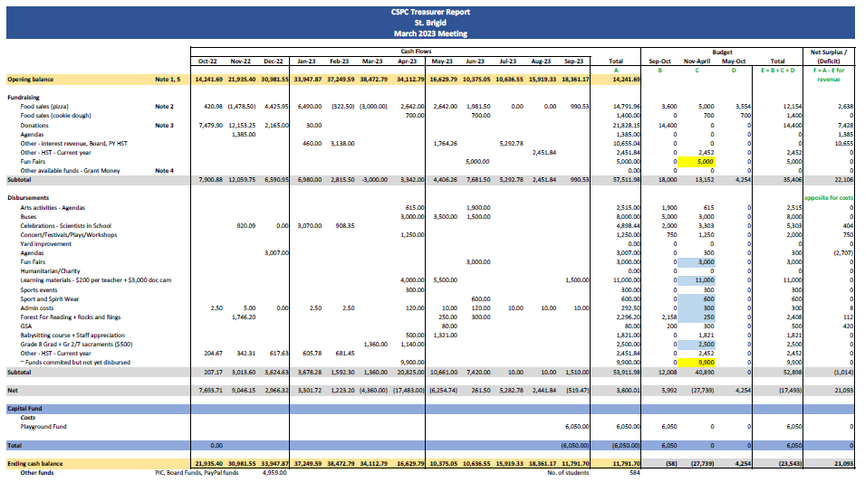

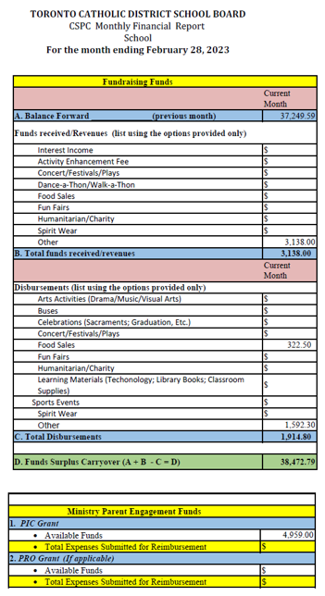
- Special Events Report
Community survey was completed with suggestions for a Family and Parent night.
A Family night is planned for April 21 to create recyclable arts. Would look to have attendees sign up on a first come first serve basis.
A proposed parent event of financial literacy date for March 23 to host a structured workshop. Cost would be $200. A second offering is related to being a good financial role model.
Motion to spend $200 of parent involvement program on presentation of Financial Literacy by Clifton Corbin. Clifton is not a CSPC member. This is funds from grant directed to parents. Kristen seconded. No opposition. Motion passed.
Fun Fair committee met after the last council meeting and we have formally set the date as Saturday June 10. 80% of respondents to survey were ok with the date. There will be a Fun Fair meeting on Wednesday, March 8. The zoom link will be shared shortly.
Additional meeting will be set for planning and to decide where to direct any funds. Event will be in the next fiscal.
- Chair’s Report
OAPCE rep is open and a nominee has come forward.
Motion to appoint Lisa ? as the OAPCE rep. Seconded by Katie. No opposition. Motion passed.
Katie went to the last OAPSCE meeting. Review of pick and pro grants that are available. Next meeting is Tuesday March 21. Lisa to attend.
Pancake Tuesday was a big hit. Thanks to all the parents who came out. 17 parents participated.
Second pizza session ends March 28. Next sign up is after March break. Volunteers have agreed to continue.
May not run the pizza day in the last week of school or during the Track and Field week.
Staff appreciation lunch proposed for Education week to avoid conflict with Fun Fair.
Mr Moulds day is coming up. No funds are required. Looking for volunteers and will send out a schedule and sign up sheet. Always looking for helmets and helmets with masks (all csa approved) so donations are welcome
- Other Business
No other business.
- Adjournment
Motion to adjourn meeting by Cheryl. Seconded by Kristen. No opposition. Meeting adjourned @ 8:34 pm.
Next Meeting: Thursday, April 20th, 2023 @ 6:30pm

