Minutes - St. Brigid Catholic School CSPC Meeting
September 27, 2023 @ 6pm In Person & via Zoom
Meeting Attendees:
In Person: Stephanie Pennington, Alana Karelson, Bekki Draper, Katie Young, Cheryl Devine, Catherine Maier, Joe Rizzuto, Irene Rizzuto, Alexandre Morel, Marcel Jar, S Sokelowski, Adam Pawlowicz, Fernando Serrano, Carmen Ceubero, Mary Rose Leishman, Sharon Lagnisma, Teresa Superville, Linda Collins-Donleavy, Josie Jamnik, Joel O’Keefe
Online participants: David Cramer, David Forsayeth were the only individuals I captured.
ANNUAL GENERAL MEETING
Topic
1. Welcome and Introductions | C. Devine & K. Young
2. Prayer and Land Acknowledgement | C. Devine
3. 2022/2023 CSPC Annual Report | C. Devine & K. Young
4. 2022/2023 Annual Financial Report | D. Cramer
5. Dissolution of 2022-23 CSPC and adjournment of AGM
Election of 2023-24 CSPC
1. Presentation of CSPC Roles and Responsibilities | C. Devine & K. Young
2. Elections for voting members of council | Election Committee Chair
2023-2024 Inaugural Meeting
1. Introduction of new parent council | New Co-Chairs
2. Principal’s Report | J Jamnik
3. Church Liaison Report | Church Rep
4. Formation of sub-committees/call for volunteers for pizza, fun fair, playground, finance | Co Chairs
5. Set CSPC meeting dates for the year | Co Chairs
6. Any other business | Co Chairs
7. Adjournment | -

Summary of Action Items from this meeting:
- Motion to dissolve the 2022/2023 council made by Cheryl. Seconded by Kristen. No opposition. Motion passed.
- Motion to approve $200 by Cheryl for Rocks and Rings classroom activity. Seconded by Kristen. No opposition. Motion passed.
- Motion to approve $600 by Cheryl for Waterloo Math Competition. Seconded by Kristen. No opposition. Motion passed.
- Motion to approve $1000 for Halloween by Cheryl. Seconded by Marcel. No opposition. Motion passed.
Meeting commenced at 6:08 PM
Annual General Meeting
1. Welcome and Introductions
Co Chair, Cheryl, welcomed everyone to the meeting and then introduced the members of the 2022/2023 council.
2. 2022/2023 CSPC Annual Report
Cheryl and Katy shared the highlights of the annual report.
3. Prayer and Land Acknowledgement
Principal Jamnik led us in a prayer.
Land acknowledgement was shared by Principal Jamnik.
Out of our deep respect for Indigenous peoples in Canada, we acknowledge that all Toronto Catholic District School Board properties are situated upon traditional territories of the Anishinabek, the Haudenosaunee, Confederacy and the Wendat peoples. We also acknowledge the land covered by Treaty 13 is held by the Mississaugas of the Credit First Nation, and Toronto is subject to The Dish with One Spoon covenant. We also recognize the contributions and enduring presence of all First Nations, Metis, and Inuit peoples in Ontario and the rest of Canada.
4. 2022/2023 Annual Financial Report
David shared the highlights from the Treasurer’s Report:
Council started year with $14K in the council bank account
We raised $69K during the year including money from the Fun Fair.
After expenses we ended the fiscal year with $41K.
Year End Financial Report
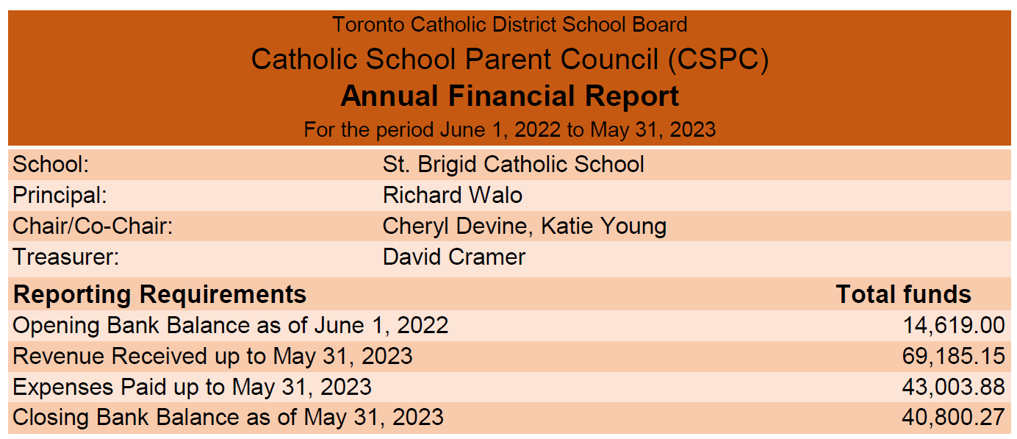

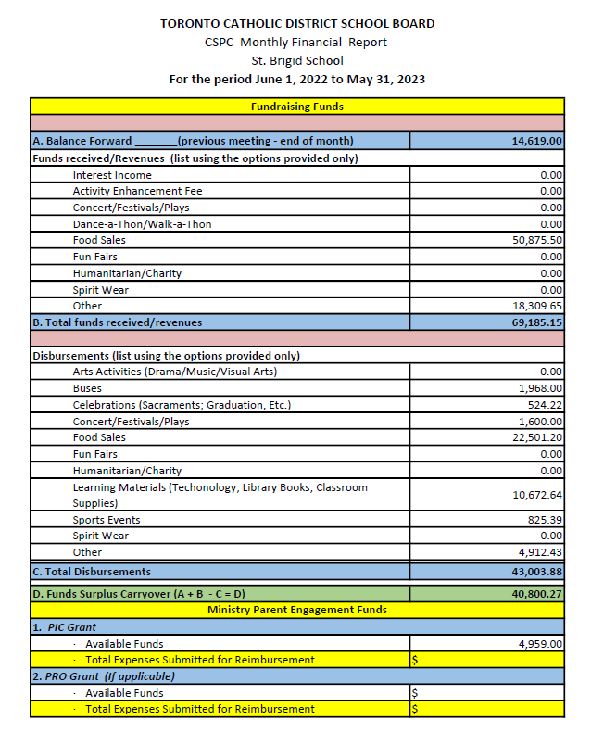

We start the year with $47K in funds on hand of which $23,800 is earmarked for playground improvements plus an additional $11K from the Board totals $34K for the playground
Funds available less playground allocations total $21K.
Council recommends having approximately $45k which equals $74 per student.
Hope is to set the next council up for success with the necessary funds
5. Dissolution of 2022-23 CSPC and adjournment of AGM
Motion to dissolve the 2022/2023 council made by Cheryl. Seconded by Kristen. No opposition. Motion passed.
Election of 2023-24 CSPC
- Presentation of CSPC Roles and Responsibilities
Cheryl presented the mandatory council positions and a summary of the responsibilities for each.
Council proposal and meeting agreement to hold open forum elections.
- Elections for voting members of council
Nominations were requested and individuals were asked to nominate or self nominate for the each role.
Nominations
Chair / Co Chair - Cheryl Washer nominates herself for Co-Chair
Cheryl nominated Stephanie Peddington as Co-Chair.
Meeting voted held – all in favor and no opposition for Cheryl and Stephanie as Co-Chairs. Cheryl and Stephanie elected as Co-Chairs.
Sharon Gisma was nominated by Cheryl for Treasurer.
Meeting voted held – all in favor and no opposition for Sharon as Treasurer. Sharon elected as Treasurer.
Joel O’Keefe was nominated for Secretary by Katie.
Meeting voted held – all in favor and no opposition for Joel as Secretary. Joel elected as Secretary.
Paula Meric nominated herself for Web and Social Media Coordinator.
Meeting voted held – all in favor and no opposition for Paula as Web and Social Media Coordinator. Paula elected as Web and Social Media Coordinator.
Alanna Karlson self-nominated for Communications Rep.
Meeting voted held – all in favor and no opposition for Alanna as Communications Rep. Alanna elected as Communications Rep.
Katy Young nominated Marcel Jar as Special Ed Rep.
Meeting voted held – all in favor and no opposition for Marcel as Special Ed Rep. Marcel elected as Special Ed Rep.
Katherine Mair and Bekki Draper self-nominated themselves for Special Events Reps.
Meeting voted held – all in favor and no opposition for Katherine and Bekki as Special Events Reps. Katherine and Bekki were elected as Special Events Reps.
Adam Pawlowicz self-nominated for Ontario Association of Parents in Catholic Education (OAPCE) Rep.
Meeting voted held – all in favor and no opposition for Adam as OAPCE Rep. Adam elected as OAPCE Rep.
Leila Stamatakis nominated herself for Church Liaison.
Meeting voted held – all in favor and no opposition for Leila as Church Liaison. Leila elected as Church Liaison.
David Forsayeth, Kristen Hawkeswood and Laura Darraga were nominated by Cheryl as Members at Large.
Meeting voted held – all in favor and no opposition for David, Kristen and Laura as Members at Large. David, Kristen and Laura elected as Members at Large.
No nomination for a Non Teacher Rep. Position will be revisited at next meeting.
Linda Collins Donleavy was nominated by Cheryl as Teacher Rep.
Meeting voted held – all in favor and no opposition for Ms. Collin Donleavy for Teacher Rep. Ms. Collins Donleavy was elected at Teacher Rep.
No nomination for a Community Rep. Position will be revisited at next meeting.
Nominations closed for CSPC council positions.
2023-2024 Inaugural Council Meeting
- Introduction of new parent council
Here is a summary of the 2023 / 2024 CSPC Elected Members
Position | Name
Co-Chair | Cheryl Devine
Co-Chair | Stephanie Pennington
Secretary | Joel O’Keefe
Treasurer | Sharon Gisma
Special Ed Rep | Marcel Jar
Special Events Rep | Bekki Draper
Special Events Rep | Katherine Mair
Web and Social Media Coordinator | Paula Meric
Communications Rep | Alana Karelson
OAPCE Rep | Adam Pawlowicz
Church Liaison | Leila Stamatakis
Member at Large | David Forsayeth
Member at Large | Kristen Hawkeswood
Member at Large | Laura Darraga
Teacher Rep | Linda Collins-Dunleavy

- Principal’s Report
Principal Jamnik shared the report below but noted that there have been some changes to staff presented at the meeting for FI4/5, Core French, and grade 7. We will be sending out information to affected parents through school messenger.

PRINCIPAL REPORT – St. Brigid School Sept 27, 2023

Thanks to all for making time to join us for our meeting this evening. Thank you for your ongoing support.

Pastoral Plan – 3 years
Walking with Christ: with Eyes of Faith and Hope, with Hearts of Kindness & Love, with Minds of Justice and Peace- We are in Year 3 “With Minds of Justice and Peace” Catholic Education is a gift –We infuse Catholicity throughout the day
We discuss and practice Catholic Graduate Expectations and Social Justice teachings

Virtues of the Month- Student – Presentation at monthly assemblies –

School Masses – booked monthly

Sacraments – information to follow

TCDSB MYSP – incorporated in our school improvement learning goals focus on -Learning, Equity, Well-Being

SIEP – review of last year plan & discuss any new focus – last year focus was math and equity – goal is to continue and build on goals focusing on Math and Equity and Inclusion

We are awaiting EQAO results from 2022-2023

Staff and Students are happy to be back together again.

Some activities:

Sports: Junior Boys/Girls Soccer; Cross Country

Gay Straight Alliance - GSA club

AV Technology Club

Choir
Current School Student Enrolment is 621 students
Staffing/Reorganization Changes due to increase in enrolment –(parent letters to be sent home on Friday Sept 29)
- Change from Gr2/3 to Gr 2 Ms. Laluck
- Change from Gr 3/4 to Gr 3 Ms. MacDonald
- Open new class Gr 4/5 - teacher TBD
- Change from 5/6 to Gr 6 – Mr. O’Callaghan

Staff Positions New and to be Filled:
FI4/5 – Ms. Alix
French Specialty – 0.3 – Ms. Alix
Core French (Ms. Sawchuk) – LTO Ms. Robichaud
Gr 7 – TBD –
Instrumental Music – Ms. Mullally has returned
Ms. Zimmerman – Primary Core French AM and Grade 8 PM – TBD
Italian – 0.5 additional position – TBD

School Budget

Basic Allocation – $41,734.00

Nutrition Program Coordinated by Julianna Morelli (lunch supervisor).
Program Available Funds with new P/M Funding – 30,169.47

Playground –
New Line Paint – completed
Mulch/Wood Chips have been ordered and waiting for delivery
Middle Primary play structure – work order has been submitted to have the equipment assessed for safety and possible repairs

Questions
Comments have been made about the Nutrition program and comments made about the eating instructions, nutritional and timing. Also questions related to allergies and allergy protocols
Coordinator is open to receive feedback and work with the parents
Suggestion to raise this topic as an agenda item for next council meeting
Cheryl mentioned there’s a need for volunteers for the nutrition program. Requests for parents to volunteer. Looking for parents to volunteer 20-30 mins in the morning after drop off
Alexander Miruel has offered to volunteer
- Church Liaison Report
Leila shared that dates have been communicated for sacrament registration. Will be included in the next newsletter.
- Formation of sub-committees/call for volunteers for pizza, fun fair, playground, finance
A call volunteers both one time and on going was made. Volunteers are specifically needed for Pizza, Fun Fair, Playground and Finance. Cheryl to send out a request for volunteers
- Any other business
Ms. Collins Donleavy shared some initial funds requests from the teachers including:

Rocks and Rings event for each class.
Motion to approve $200 by Cheryl. Seconded by Kristen. No opposition. Motion passed.

Waterloo Math Competition (grades 5-8 at a cost $5 a student).
Motion to approve $600 by Cheryl. Seconded by Kristen. No opposition. Motion passed.

Raptors 905 game – Dec 1 - $20 per students. Approval discussion deferred to next meeting.

Teachers looking for Makey Makey devices – approximate $500 – will hold for future decision

Grade 4 teachers looking for Medieval Times trip. Decision deferred for future meeting

Halloween dance. Dance format of hourly slots assigned by grade. Some concerns around students who don’t celebrate Halloween.
Motion to approve $1000 for Halloween by Cheryl. Seconded by Marcel. No opposition. Motion passed.
6. Set CSPC meeting dates for the year
Agreement to hold meetings on the 3rd Tuesday each month of the school year with the exception of December and March.
Council Meetings for 2023 / 2024 set as follows:
Month | Date and Time
October | Tuesday, October 17, 2023
November | Tuesday, November 21, 2023
January | Tuesday, January 16, 2024
February | Tuesday, February 20, 2024
April | Tuesday, April 16, 2024
May | Tuesday, May 21, 2024
June | Tuesday, June 18, 2024

7. Adjournment
Motion to adjourn by Cheryl. Seconded by Katy. No opposition, Motion Carried – meeting adjourned at 7:52 PM
Next Meeting: Tuesday, October 17, 2023 @ 6:30pm.

