Minutes - St. Brigid Catholic School CSPC Meeting
November 21, 2023 @ 630pm In Person & via Zoom
Meeting Attendees:
In Person: Stephanie Pennington, Kristen Hawkeswood, David Forsayeth, Katie Young, Bekki Draper, Cheryl Devine, Leila Stamatakis, Paula Merrick, Marcel Jar, Adam Pawlowicz, Principal Alonzi, Vice Principal Brown, Catherine Maier, Eileen Cramer, Joel O’Keefe
Online participants: Linda Collins-Donleavy, Lena Knight, Bellamy Lacay, Kelly Sequeira, Renee Fergussen, Michelle Mifsud, Karolina Martinez, Lena Knight, Laura Hincapie
 | ANNUAL GENERAL MEETING
Topic |  |  | Time
1. Welcome, Opening Prayer & Land Acknowledgement |  | Principal Alonzi & VP Brown | 6 :30
2. Introductions |  | S. Pennington | 6:35
3. Review of October Minutes; Stating of Other Business |  | S. Pennington | 6:40
4. Special Guests - Student Association Reps |  | Isabel P-B, Gabriella G, and Saron T | 6:45
5. Principal and Vice-Principal’s Report  a. Playground Update  b. Academic Update  c. Christmas Events |  | Principal Alonzi & VP Brown | 7:00
6. Teachers Representative Report |  | Ms. Collins-Don Leavy | 7:15
7. Web & Social Media Report  a. Media Strategy  b. Online Media Plan (Slide Presentation) |  | P. Merrick | 7:20
8. Treasurers Report 7:30  a. Budget Update/Review  b. Upcoming HST review (Board) |  | C. Devine | 7:30
9. OAPCE Report |  | A. Pawlowicz | 7:40
10. Chairs Report  a. Fun Fair  b. Upcoming Help |  | K. Hawkeswood  S. Pennington | 7:50
11. Any other business
12. Adjournment

Summary of Action Items from this meeting:
- Motion to approve October minutes by Cheryl. Seconded by Marcel. No opposition. Motion approved.
- Motion to approve $500 for Sports, Events and Clubs for the diversity day from Cheryl, Seconded by Kristen. No opposition. Motion passed.
- Motion to approve budget and allocate funds as outlined in the budget proposal by David, seconded by Kristen. No opposition. Motion passed.
Meeting commenced at 6:32 PM
- Welcome, Opening Prayer & Land Acknowledgement
Meeting commenced with a prayer by Principal Alonzi followed by the Land Acknowledgement read by VP Brown.
- Introductions
Introductions of council were deferred.
Additional guests from the Student Council were introduced – Please share student names
3. Review of October Minutes; Stating of Other Business
Minutes to be posted online prior to the meeting going forward
Motion to approve October minutes by Cheryl. Seconded by Marcel. No opposition. Motion approved.
Additional business to be added:
Math course review and approval
Playground grant request
4. Special Guests - Student Association Reps
Multicultural Celebration proposal from BSA. Slides to be shared to be included in the report.
Request to have a Multi Cultural event in May
Start up Funds are requested - $500 as well as parent and communication support
Q - Have you looked into local printers? No but can.
Event would be during day time.
Q - Would be for all grades? Yes
Q - How will you pick the countries? Propose a survey.
Suggestion to consider using regions instead of countries.
Lena Knight would like to volunteer to help the group with their proposal.
Wonderful way to share the diversity of the school
Kelly also interested in volunteering.
We can earmark funds for the event and then formally approve the request
Motion to approve $500 for Sports, Events and Clubs for the diversity day from Cheryl, Seconded by Kristen. No opposition. Motion passed.
Students presented two other events:
Spirit Week and Selling Candy Canes
Money to be raised for grade 8 grad
Suggestion for a ginger bread house decoration event
5. Principal and Vice-Principal􀂶s Report
a. Playground Update
Principal shared the Environmental Special Services oversee the maintenance and operations of playgrounds and has made a decision and that we will be moving forward with a quote to either repair or replace. Commitment to repair has been made. Expectation is to be completed over the next few weeks. Principal will keep us posted
Application for the playground grant has not been posted yet.
Board will evaluate the application and a team will assess and make a decision.
Expectation is that the grant application will need to be submitted prior to the next meeting. Requires two staff reps which we have a commitment from. Will also need the Principal / VP involvement. VP Brown has committed to support.
Safety concerns should be included in the application as they will be factored into the assessment of applications.
Concerns around the drainage in the yard have been captured and should be addressed through the application process. We may want to include additional improvements as part of the application.
Suggest we hold a separate meeting to strategize on the playground application
Concern about balls not being allowed in the yard. “Soft” balls have been ordered for use in the yard.
Rotation schedule in place for soccer playing. 1&2’s on T & T and 3&4’s on M, W, F.
Commitment to review safety concerns after new balls are in place.
b. Academic Update
Math resource coach met with a group of teachers. Reviewed the list of questions and highlighted “thinking” questions. Will leave the initiative with the staff and have them pick 3-5 students (at lower level) to assess. Template will be shared for thinking will be reviewed during Dec PA Day.
Evaluated other concerns related to the testing.
Plan moving forward with teachers watching students and capturing concerns that will be shared to better evaluate computation strategies.
Q - Similar approach was done last year. Was an evaluation and review of the results done and lessons learned shared and applied this year? Yes
c. Staffing
French Immersion – Ms Robichaud is now .3 specialty in the mornings along with her current placement of 0.5 in the afternoon.
Grade 4/5 class English teacher won’t be returning. Currently looking for a replacement.
Looking to fulfill an open position permanent. In the interim there will be an occasional teacher in place.
Grade 8 – Ms Zimmerman will be gradually returning to work to 0.5. Ms Zeleski Cox had stepped in and will be transitioning out.
Ms. McGhee will be off for personal reasons for some time.
Replacing teachers who are off is the top priority.
How long is the principal in place. For the time being?
Goal date for Ms Zimmerman transition. Hopefully January full return
Will there a communication going to the 4/5 parents?
Ms. Brown has sent an update to the parents involved today.
c. Christmas Events
No commitment yet until a conversation is needed with the staff. Staff meeting is scheduled for tomorrow. More information to come. Council is happy and willing to help out.
Events are planned – Advent mass, spirit week, advent wreath lightning, Santa visit.
May be a request for donations for gift cards to be distributed to needy community families
6. Teachers Representative Report
Ms. Collins Donleavy.
Had second Waterloo Math competition and the students did really well.
Looking into making a math wall to encourage students to get talking about math
Skating days are coming up. March 28th is Mr Moulds day. May look for support for hot chocolate.
Raptors 905 day coming up.
Anti Bullying week – communications and discussion on anti bullying were held.
No specific asks from Teachers to share other than a teacher allotment
7. Web & Social Media Report
a. Media Strategy
b. Online Media Plan (Slide Presentation)
Review of the online media plan
Survey with 42 respondents
Content created by council, approved and then shared through web site or newsletter
Preferred communication method is through the newsletter
Mix of response on the cadence of the newsletter
Frequency of visiting the website – rarely or never
What should be shared – school events, volunteer opportunities, board meeting updates, upcoming community events, fundraising
Large majority would like heads up
Other methods of communication – text, twitter, etc
Very positive feedback was shared.
Can we attach the website link in the newsletter going forward
Website traffic is picking up during the year
Social Media Guidelines
- Any new social media channel needs to be approved by the Principal and aligned with the Board
- No personal information can be included
- Focus should be on celebrating student success, dates, events, etc
- Can’t endorse any businesses.
Proposal to create a Facebook page and Instagram account with the commitment to follow board guidelines and protocols.
Q - Can we post pictures? Must have written consent.
Suggestion to use site for announcements and turn off comments – school calendar
Thanks for Paola for the effort on the survey and the proposal.
Table this for a later discussion.

8. Treasurers Report 7:30
a. Budget Update/Review

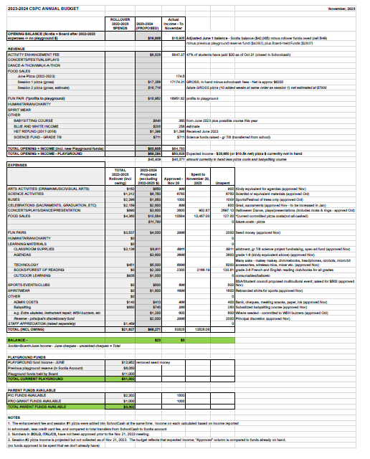
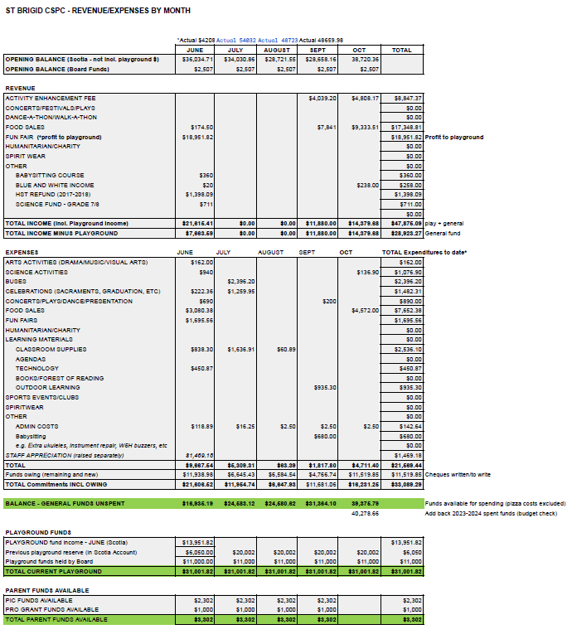
Pizza purchases still to go through
Current balance - $40,000
Account needs to be reconciled
Approvals for the following items are requested:
- Arts Activities
- Celebrations
- Fun Fair
- Classroom Supplies
- Agendas
- Technology
- Spiritwear
Motion to approve budget and allocate funds as outlined in the budget proposal by David, seconded by Kristen. No opposition. Motion passed.
b. Upcoming HST review (Board)
HST Review upcoming – prepping for the review.
9. OAPCE Report
Adam participated in the recent meeting
Good session
Two requests - to sign up for the updates and newsletters.

10. Chairs Report
a. Fun Fair
Planning a meeting for an info night. Will start making plans and requesting volunteers
11. Any other business
Math night potentially as a family night.
Potentially a speaker for home and school math strategies. Is the author of Math Up
Will likely make a request for $600 for a zoom session with the speaker
Could we record and share with other parents.
Plan to go ahead and book the speaker for a Math Parent Night
Babysitter course has been allocated and will be booked.
12. Adjournment
Motion to adjourn by Kristen. Seconded by David. No opposition, Motion Carried – meeting adjourned at 8:37 PM
Next Meeting: Tuesday, January 16, 2024 @ 6:30pm.

