Minutes - St. Brigid Catholic School CSPC Meeting
February 20, 2024 @ 630pm In Person & via Zoom
Meeting Attendees:
In Person: Principal Kerr, Kristen Hawkeswood, Katie Young, Cheryl Devine, Linda Collins-Donleavy, Catherine Maier, Leila Stamatokis, Marcel Jar, Joel O’Keefe
Online participants: Stephanie Pennington, Adam Pawlowicz, Alana Karlson, Bekki Draper, David Forsayeth, E Kelly, Eileen Cramer, Karolina Kosecki, Laura Hincapie, Michelle Mifsud, Paola Merrick, Sharon Laguisma, Tara Ardila
Agenda
Topic |  | Time
1. Welcome, Opening Prayer & Land Acknowledgement | Principal Kerr & VP Brown | 6 :30
2. Introductions | S. Pennington | 6:35
3. Review of January Minutes; Stating of Other Business | S. Pennington | 6:40
4. Principal and Vice-Principal’s Report  a. Playground Update  b. Academic Update  c. Staffing Updates  d. Funds | Principal Kerr & VP Brown | 7:00
5. Teachers Representative Report | Ms. Collins-Don Leavy | 7:15
6. Treasurers Report  a. HST Claim Update  b. Spending & Budget Update  c. Recent PCI/PRO Grant Claim Changes  d. Pizza Update | C. Devine, S. Laguisma | 7:20
7. Special Events  a. Fun Fair  b. Teacher Appreciation Lunch | B. Draper, C. Maier | 7:30
8. Playground Grant Update
9. Chairs Report  a. Upcoming Help Needed | K. Hawkeswood  S. Pennington | 7:50
9. Other business
10. Adjournment

Summary of Action Items from this meeting:
- Motion to approve January minutes by Kirsten. Seconded by Katie. No opposition. Motion approved.
- Motion to allocate $6,050 in funds for additional expenses by Cherly, Seconded by Kristen. No opposition. Motion approved.
- Motion to adjourn by Kirsten. Seconded by Katie. No opposition, Motion Carried – meeting adjourned at 8:23 PM
Meeting commenced at 6:32 PM
- Welcome, Opening Prayer & Land Acknowledgement
Meeting commenced with a prayer by Principal Kerr followed by the Land Acknowledgement.
- Introductions
Introductions of council were deferred.
3. Review of January minutes; Stating of Other Business
Motion to approve January minutes by Kirsten. Seconded by Katie. No opposition. Motion approved.
- Principal and Vice-Principal’s Report
Staffing and School Data
No open position in the school at this time. Thanks to the HR department for all their help.
- Welcome Ms. Talamor as the LTO for Ms. McGhee’s EF4/5 and Junior Special Education
- We now have no open positions.
- Current enrollment of 631 students.
- 60 Kindergarten Registrations.
Depending on the registration and modeling we may have 5 kindergarten classes next year.
TCDSB
- Staffing process for the 2024-25 school year begins in March.
Class size determination will be done in March which will drive staffing requirements.
St. Brigid Updates
- A huge thanks on behalf of the school to CSPC and all the parent volunteers for Shrove Tuesday Pancakes.
- Individual teacher meetings are complete. Meetings were a review of Math resources/programming, students in need, and a chance to discuss overall classroom needs.
- Ms. Brown and I will be joining every class over the new two weeks for a Math class. This is a chance for us to get familiar with resource usage and classroom progress.
- We are planning on adding a “Student Support” catalog item to School CashOnline. It would be set-up as a $10 item that can be purchased multiple times. The funds will be used to subsidize families in need for trips and activities. We will provide a regular accounting of the amount raised and how much has been used. This was an important support at my previous school.
- Three new projectors have been ordered and delivered. Two have gone to classrooms in need and the third will be housed in the office for presentations. More to be ordered.
- BSA (Black Student Alliance) is making daily announcements and running a trivia competition for African Canadian Heritage month. Their activities will culminate in the Black Excellence Fair on February 27th.
- Staff making use of the TCDSB Black History 365 resources: https://www.tcdsb.org/o/communityrelations/page/african-canadian-heritage
- Our Area 6 Reading Facilitator spent the day at St. Brigid on Tuesday February 20, 2024 supporting English side K to Grade 3 class with the new curriculum. There will be more visits to come.
Teacher discussion were completed and the response was a need for math support.
Squishy balls have been ordered and have arrived and will be distributed to replace soccer balls to be used in the yard.
Is there an opportunity to add a second container to store materials (balls) in the yard?
Yes, this can be reviewed for funding.
Facilities
- Gym ceiling is being repaired during March Break.
- Entire gym will be painted during March Break as well.
- Electrical upgrade commencing during March. Nothing during the school day - all work during evenings.
Any update on the playground?
Principal Kerr said no further update other than the pervious commitment that it will be addressed this year. This is reference to the structural changes that need to be fixed.
- Teacher’s Representative Report
No request for funds.
There is a plan to do a musical which may need some support and funding for backdrops and props.
Upcoming ski trip for grade 8’s in March which may require some funding to offset the cost. These funds should come from grade 8 fundraisers already completed.
M Collins Donleavy attended a Mental health workshop and received some material that will be shared with the students.
Thanks to Parent Council for support with Valentines Day and our Carnival.
Mr Moulds skating day is coming up and adult skates are needed.
- Treasurers Report
Cheryl reviewed the balance summary
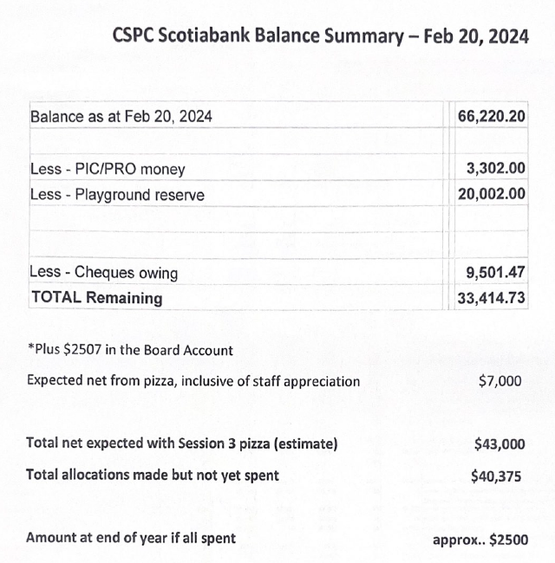
We have a total $33,414 of unspent money but not unallocated.
Expected income from pizza is $7,000.
Total allocations are estimated to be $40,375 which would leave us with $2,500.
Based on the projections we are able to up our budget on a few items.
Scientist budget should be increased by $150 to cover higher costs.
Teachers still looking to book will be reminded to book events with a suggested budget of $250 - $275.
Need to increase the grad gift budget by $400.
Fun Fair budget should be increased by $1,000. We should get the Fun Fair money back in May.
How much did we make last year? $13,000 in profit last year.
We need to up the budget by $500 for STEM expenses.
We could allocate additional funds for balls towards a container and other toys. Looking to allocate an additional $1,000 for outdoor play.
Spirit wear that has been previously sold could be used as school wear.
Gender equity shirts or house shirts could be order to be worn in the school.
Current Spirit Wear budget may be a little low and need to be supplemented in order to make this years order. We’re waiting on the school logo to be included as part of the spirit wear.
Need to replace the current inventory of shirts with a new batch.
$1,200 is set aside for teacher appreciation which had been approved previously online.
$300 for Pancake Tuesday was approved online.
Need to allocate an additional $1,500 for buses for Mr Moulds.
Are we ok to bring the funds close to zero and request for additional funds later if needed.
Motion to allocate $6,050 in funds for additional expenses by Cherly, Seconded by Kristen. No opposition. Motion approved.
- Special Events Report
Fun fair is booked for June 1 from 12-3. Planning committee is in place with about 20 parent volunteers already signed.
Save the date to bring your kids and please volunteer if possible.
Any gifts that can be donated would be greatly appreciated.
Also if there are any community business connections that could be shared to request for gifts.
Mr Moulds day is March 28th which is Holy Thursday. Needs to assess if this is an issue.
Need to coordinate a sign up sheet for skates. Ms CD to arrange a google form.
Looking for parent volunteers to help on the day of the skate to assist with tying skates.
Not a lot of interest for a Math night but however we could do a coding night if we used computers from the school. Would be a nice community night but would need volunteers to help with logistics.
Cheryl will lead but needs some help. We can ask for a donation that could go to offset other technology needs. Cheryl to look into dates and time (look to do a 630 start time).
Staff appreciation lunch is proposed for early June and will require volunteers
- Playground Grant Update
Mid April is when the playground application is due to the Board. Need to show quotes to substantiate the request. Looking for some help to finalize the application through the Playground committee. Mr. Kerr to lead the submission.
- Chair’s Report
Next Fun fair committee meeting planned for tomorrow at 7pm.
- Other Business
Church Update
Reconciliation
Reminder that the ceremony will be held on February 22nd at 6:30pm. Students who will be receiving the sacrament are asked to arrive at the church at 6:15pm and wait for further instruction from Father Shibil.
First Communion
The next 5 communion classes will resume on March 2. Dates are as follows: March 2, March 23, March 30, April 13, April 20, April 25
Rehearsal is April 25, Ceremony is April 27
Confirmation
- 2 classes remain on February 24th and March 9th, along with a retreat on April 6th
- Father Shibil has requested that all confirmation students attend mass Saturday at 5pm OR Sundays at 11am. Attendance will be taken every week by the catechists. This is Father's request as there has been very low mass attendance, and given that this is such an important sacrament where students are reaffirming their commitment to the faith, Father would like to highlight the importance of attending mass. Students may simply attend, or if they wish, are encouraged to continue to volunteer as ushers or altar servers.
- Stations of the Cross take place every Friday evening at 7pm at the church, and families are welcome to join.
- Father Shibil has requested that all confirmation students lead the Stations of the Cross mass on Friday March 22nd at 7pm. The students will pray the 14 stations from beginning to end during this mass.
In order for students to learn how to pray the Stations of the Cross, there will be 3 practices ahead of this to prepare. The first 2 practices will be done during their regular classes on Saturday February 24th and Saturday March 9th from 10am-12pm. The 3rd practice will be held on Saturday March 16th from 3-4:45pm in the Church.
Passion Play
- A reminder that preparations for the Passion Play (held on Good Friday) are underway. Anyone who wishes to assist can contact the church office. The church also encourages families to attend the play that day.
Lent Confessions
These will be held on March 23rd at 10am-12pm and 2:30pm-4:30pm for all those who have received the sacrament of reconciliation.
- Families are encouraged to attend.
- Adjournment
Motion to adjourn by Kirsten. Seconded by Katie. No opposition, Motion Carried – meeting adjourned at 8:23 PM
Next Meeting: Tuesday, April 16, 2024 @ 6:30pm.

