Minutes - St. Brigid Catholic School CSPC Meeting
June 18, 2024 @ 630pm (In person and via Zoom)
Meeting Attendees:

In person: Principal Kerr, Stephanie Pennington, Kristen Hawkeswood, Katie Young, Marcel Jar, Cheryl Devine, Linda Collins-Donleavy, Catherine Maier, Marcel Jar, Adam Pawlowicz, Leila Stamatakis, David Forsayeth, Flora Cifelli, Superintendent of Education (Area 6).
Online participants: Vice Principal Melissa Brown, Bekki Draper, Michelle Mifsud, Rosa, Tara Ardila, Sharon Laguisma, Paola Merrick, Daniel Tesfaye
Agenda
Topic |  | Time
1. Welcome, Opening Prayer & Land Acknowledgement | Principal Kerr | 6:30
2. Introductions | K. Hawkeswood | 6:32
3. Review of May Minutes; Stating of Other Business | S. Pennington | 6:33
4. Principal’s Report  a. Academic Update - EQAO  b. Staffing Updates  c. Heating & Contingency Plan | Principal Kerr | 6:43
5. Teachers Representative Report  a. Request for Fall bookings | Ms. Collins-Don Leavy | 7:00
6. OACPE Check In |  | 7:10
7. Treasurers Report  a. Fiscal year end  b. Incidental fee for 2024/2025 school year | C. Devine, S. Laguisma | 7:15
8. Fall fundraising & Pizza |  | 7:30
9. Daryl Devonish: Multisport Training & Phys Ed Challenge |  | 7:33
10. Special Events  a. Fun Fair Debrief  b. Staff Appreciation Lunch | B. Draper | 7:35
11. Playground Update | K. Hawkeswood  S. Pennington | 7:45
12. Chair’s Report  a. Banking for 2024/25  b. Italian Heritage Language  c. Set date for September meeting, Curriculum Night | K. Hawkeswood  S. Pennington | 7:55
13. Other Business |  | 8:00
14. Adjournment

Summary of Action Items from this meeting:
- Motion to approve May minutes by Stephanie. Seconded by Katie. No opposition. Motion approved.
- Motion to allocate $400 to the graduation funds by Cheryl. Seconded by Kristen. No opposition. Motion approved.
- Motion to propose a position on CSPC for a Fund Raising Lead who will be responsible for Pizza Days by Cheryl. Seconded by Kristen. No opposition. Motion approved.
- Motion to propose $400 for a new online bank account by Cheryl. Seconded by Katie. No opposition. Motion approved. This could be a reoccurring annual charge.
- Motion to propose $150 to book bike event by Cheryl. Seconded by Kirsten. No opposition. Motion approved.
- Motion to adjourn by Kirsten. Seconded by Katie. No opposition, Motion approved – meeting adjourned at 8:38 PM
Meeting commenced at 6:33 PM
- Welcome, Opening Prayer & Land Acknowledgement
Meeting commenced with the Land Acknowledgement followed by a prayer for Faithfulness by Principal Kerr.
- Introductions
Introductions were done by the Council members.
3. Review of May minutes; Stating of Other Business
Motion to approve May minutes by Stephanie. Seconded by Katie. No opposition. Motion approved.
No other business to be added to the agenda.
- Principal and Vice-Principal’s Report
STAFFING & School Data:
We say good-bye to PERMANENT TEACHERS: Mr. Tigley, Mme. Falsetti, Mme. Sawchuk, Mme. McKenzie, and Ms. Kuszner. LTOs: Ms. Johnston, Ms. Moultray, Ms. Lobo, Mr. Baglio, Mme. Alix, and Mme. Guadagni.
We welcome Mme. McKenzie (FSL) and Mr. Creaghan (0.3 French Specialty).
Open positions to fill: Grade 7, Grade 8, 0.5 Grade 8, FSL, 0.5 FSL, and FI Grade 3.
Positions to be filled through surplus or new hires.
Current enrollment of 627 students.
TCDSB UPDATES: Offices reopen during the week of August 26, 2024.
St. Brigid UPDATES: Office remains open during the first week of July.
Gym available as a cooling zone. Staff on the third floor to use for at least one respite period per day.
FACILITIES:
As mentioned in the Community Update, air quality tests and material sample tests came back clear.
Project has not restarted since last week’s issues..

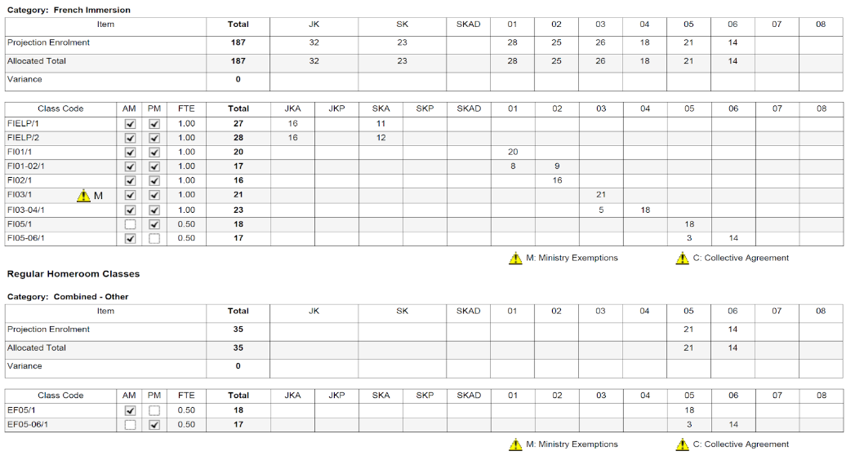
- Teacher’s Representative Report
Thanks to the Council for their generous teacher contributions
W5H participation again and another win.
Thanks for an awesome Fun Fair. Good time had by all.
Request for teachers to book events for next year.
- OAPCE Check In
Continue to ask for volunteers and include updates in the newsletter.
- Treasurers Report
Cheryl shared report as of May 31.
Fun Fair was June 1 so there is some income still to be accounted for.
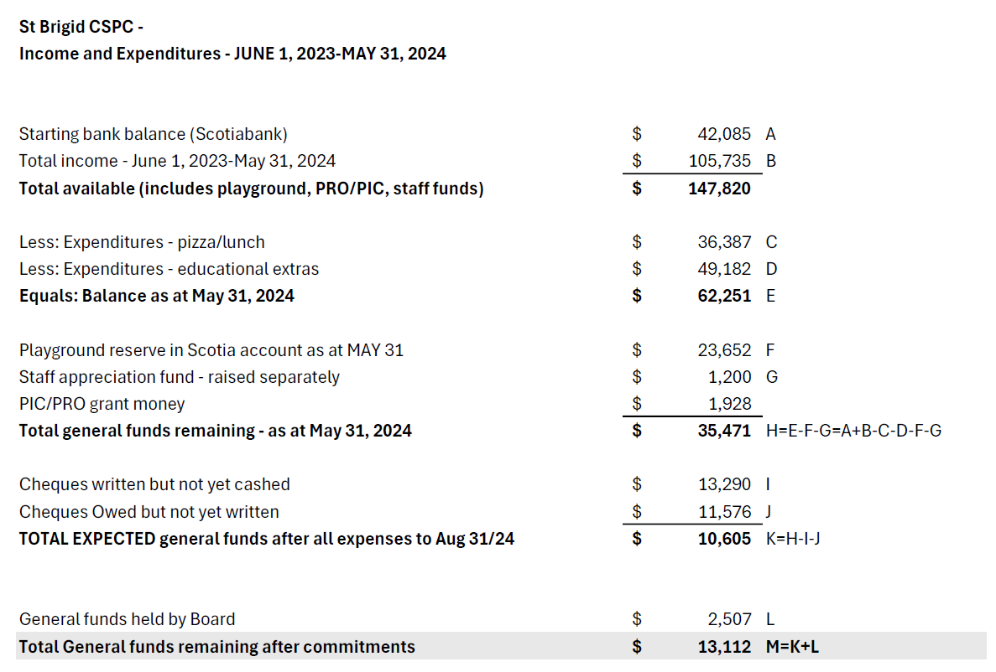
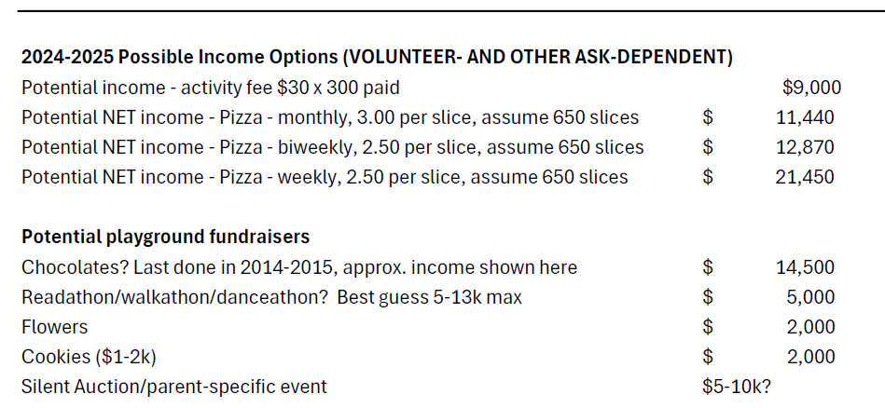
Should consider moving Playground funds over to the Board for awareness and visibility.
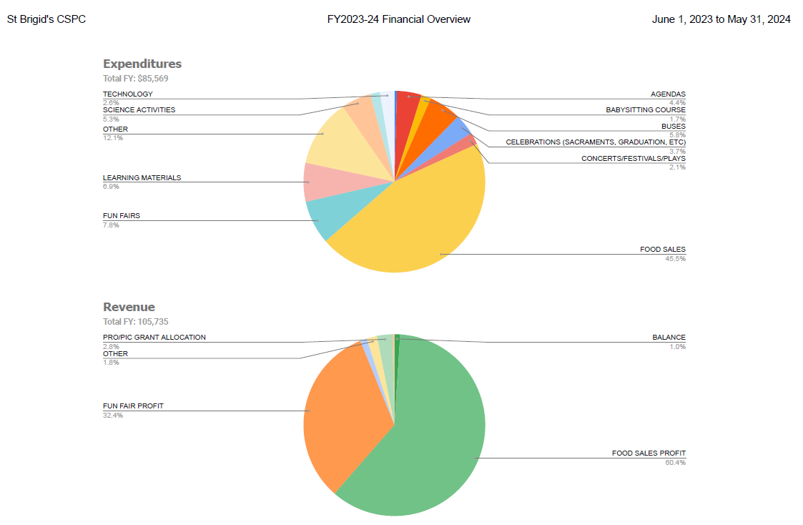

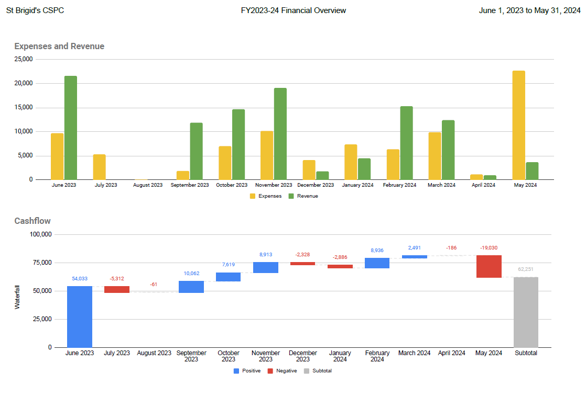

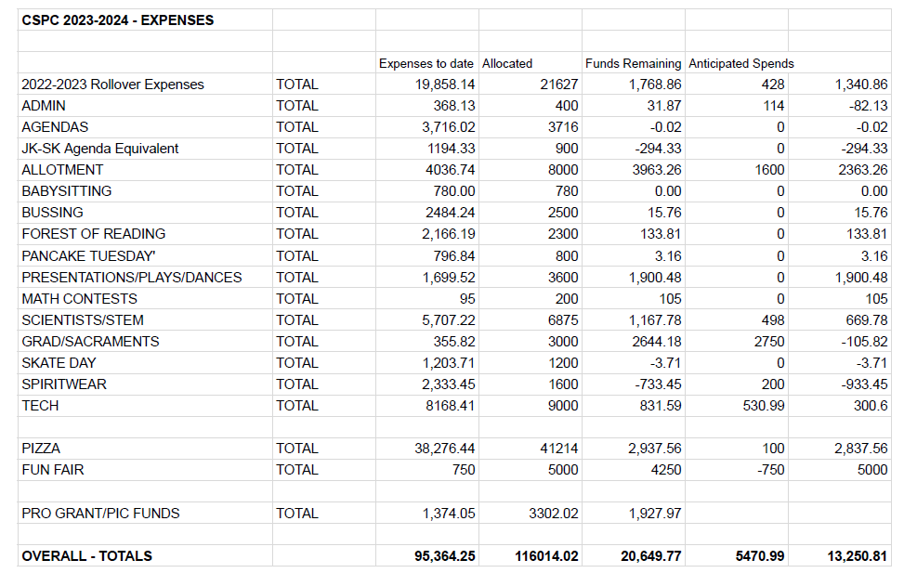
Principal Kerr confirmed that a survey is being sent out to determine student needs for agendas. Will order for 1-5 and then ask for 6-8.
Motion to allocate $400 to the graduation funds by Cheryl. Seconded by Kristen. No opposition. Motion approved.
Request to store supplies for graduation centrally at the school.
- Fall Fundraising & Pizza
Request for Ms. Collins-Donleavy, Principal Kerr and VP Brown to meet with Finance Committee to review and make a recommendation for next years incidentals.
Pizza will remain our main revenue source. Will require a Pizza Lead next year and should ideally be on council. A request for a volunteer should be made.
Motion to propose a position on CSPC for a Fund Raising Lead who will be responsible for Pizza Days by Cheryl. Seconded by Kristen. No opposition. Motion approved.
Request to review the potential playground fundraisers shared by Cheryl.
- Daryl Devonish: Multi Sport Training & Phys Ed Challenge
Cheryl introduced Daryl Devonish who proposed an after school muti sport camp. Used as a tool to get kids active. 2-3 times a week for different classes offering different sports. Component of teaching fundamentals and a game at the end of the session.
90 minute session after school in the gym. Class is tailored to 20-25 students. Have partnered with the NHL to have NHL street program in the school. Option to also do the program during school hours.
PK open to meeting with Daryl on developing a proposal.
Definite interest in getting Daryl in to talk to kids / parents about getting active or introducing a fitness program.
- Special Events Report
- Fun Fair
Thanks to everyone for all the hard work, donations, teachers and presentations.
599 packs of $20 tickets
Suggestion to solicit feedback from volunteers, students, etc. for feedback on the Fun Fair.
Could look for additional volunteers to take lead roles.
- Staff Appreciation Lunch
Lots or parents have stepped up and volunteered for Fridays event. Food and donations are still welcome.
- Playground Update
May 24 application was submitted. Survey was sent out and incorporated into the application.
Request was submitted for $50,000. Unsure of timing on approval notification.
Parks group coming to complete an assessment on the yard on June 20.
- Chair’s Report and Other Business

- Banking for 2024/25
Request to move to online banking account to reduce the reliance on monthly paper updates. Cost would be between $30-$50 per month.
We should look into account options at other backs to see how we can limit banking fees going forward and moving online.
Motion to propose $400 for a new online bank account by Cheryl. Seconded by Katie. No opposition. Motion approved. This could be a reoccurring annual charge.
- Set date for September meeting, Curriculum Night
Suggestion to add CSPC information session prior to the AGM for interested parties and solicit committee members.
Propose meet and greet week of September 17th, 2024 @ 630pm.
AGM proposed for Tuesday, September 24th, 2024 @ 630pm.
Nominations forms will be sent out 2 weeks prior to the AGM.
- Other Business
Bike blender activity to be booked for September.
Motion to propose $150 to book bike event by Cheryl. Seconded by Kirsten. No opposition. Motion approved.
- Adjournment
Motion to adjourn by Kirsten. Seconded by Katie. No opposition, Motion approved – meeting adjourned at 8:38 PM
Next meeting proposed for Tuesday, September 24th, 2024 @ 630pm.

